

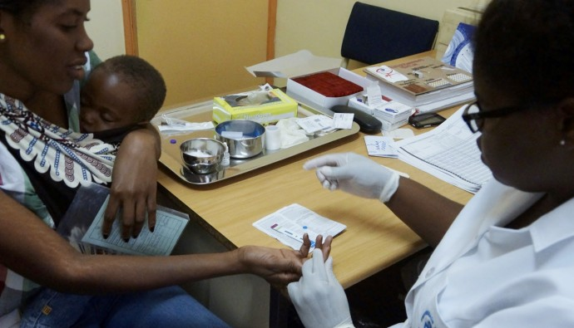

**FY 2018 DATA QUALITY ASSESSMENT**

Family Health International 360 (FHI360)

Strengthening Integrated Delivery of HIV/AIDS Services (SIDHAS)

Final Report Submitted: November 15, 2018

*This page is intentionally left blank.*

# TABLE OF CONTENTS

TABLE OF CONTENTS V

LIST OF TABLES viii

LIST OF FIGURES ix

Acronyms 1

1 Executive Summary 3

1.1 INTRODUCTION, PURPOSE AND METHODOLOGY 3

1.2 FINDINGS 4

1.3 CONCLUSION 6

2 Introduction and purpose of the DQA 7

2.1 DATA QUALITY STANDARDS 8

2.2 OBJECTIVES OF THE DQA 9

2.3 INDICATORS ASSESSED 9

2.4 PERIOD OF THE DQA 9

2.5 THE PEPFAR INTERAGENCY DATA VALIDATION EXERCISE 10

2.6 THE SIDHAS ACTIVITY 10

3 METHODOLOGY 13

3.1 SAMPLING METHODOLOGY FOR SITE SELECTION 13

3.1.1 INCLUSION CRITERIA 13

3.1.2 EXCLUSION CRITERIA 13

3.2 SAMPLE SIZE 13

3.3 DQA PROCESS (MEL ACTIVITY DQA TEAM) 14

3.3.1 M&E SYSTEMS ASSESSMENT 14

3.3.2 APPLICATION OF THE FIVE DATA QUALITY STANDARDS 15

3.4 PEPFAR INTERAGENCY DATA VALIDATION EXERCISE METHODOLOGY 15

3.5 DQA TOOL 15

3.6 DATA ANALYSIS 16

3.7 OTHER OPERATIONAL CONSIDERATIONS FOR DQAS 16

4 FINDINGS 18

4.1 M&E SYSTEMS ASSESSMENT – SIX FUNCTIONAL AREAS 18

4.1.1 SIDHAS CENTRAL M&E UNIT 18

4.1.1.1 M&E STRUCTURE, FUNCTIONS, AND CAPABILITIES 18

4.1.1.2 INDICATOR DEFINITION AND REPORTING GUIDELINES 18

4.1.1.3 DATA COLLECTION AND REPORTING FORMS AND TOOLS 18

4.1.1.4 DATA MANAGEMENT PROCESSES 18

4.1.1.5 LINKS WITH THE NATIONAL REPORTING SYSTEM 19

4.1.1.6 USE OF DATA FOR DECISION MAKING 19

4.1.1.7 STRENGTHS – SIDHAS CENTRAL M&E UNIT 19

4.1.1.8 AREAS FOR IMPROVEMENT – SIDHAS CENTRAL M&E UNIT 20

4.1.1.9 RECOMMENDATIONS – SIDHAS CENTRAL M&E UNIT 20

4.1.2 SIDHAS STATE-LEVEL M&E SYSTEM 20

4.1.2.1 M&E STRUCTURE, FUNCTIONS, AND CAPABILITIES 20

4.1.2.2 INDICATOR DEFINITION AND REPORTING GUIDELINES 20

4.1.2.3 DATA COLLECTION AND REPORTING FORMS AND TOOLS 21

4.1.2.4 DATA MANAGEMENT PROCESSES 21

4.1.2.5 LINKS WITH THE NATIONAL REPORTING SYSTEM 21

4.1.2.6 USE OF DATA FOR DECISION-MAKING 21

4.1.2.7 STRENGTHS - SIDHAS STATE LEVEL 23

4.1.2.8 AREAS FOR IMPROVEMENT - SIDHAS STATE LEVEL 23

4.1.2.9 RECOMMENDATIONS - SIDHAS STATE LEVEL 24

4.1.3 SIDHAS SERVICE DELIVERY LEVEL (HEALTH FACILITIES) 24

4.1.3.1 M&E STRUCTURE, FUNCTIONS, AND CAPABILITIES 24

4.1.3.2 INDICATOR DEFINITION AND REPORTING GUIDELINES 24

4.1.3.3 DATA COLLECTION AND REPORTING FORMS AND TOOLS 24

4.1.3.4 DATA MANAGEMENT PROCESSES 24

4.1.3.5 LINKS WITH NATIONAL REPORTING SYSTEM 25

4.1.3.6 USE OF DATA FOR DECISION-MAKING 25

4.1.3.7 STRENGTHS 26

4.1.3.8 AREAS FOR IMPROVEMENT 26

4.1.3.9 RECOMMENDATIONS 27

4..2 DATA QUALITY STANDARDS – SIDHAS 27

4.2.1 VALIDITY 27

4.2.1.1 UNDERSTANDING THE INDICATOR DEFINITIONS 27

4.2.1.2 DATA COLLECTION AND REPORTING 28

4.2.1.3 DOES THE INFORMATION COLLECTED MEASURE WHAT IT IS SUPPOSED TO MEASURE? 28

4.2.1.4 STORAGE OF DATA 29

4.2.1.5 DATA VALIDATION BY THE PEPFAR INTER-AGENCY EXERCISE 29

4.2.1.6 QUALITATIVE FINDINGS FROM THE PEPFAR INTERAGENCY EXERCISE 35

4.2.2. INTEGRITY 35

4.2.2.1 MECHANISMS TO ENSURE DATA INTEGRITY 35

4.2.2.2 AREAS FOR IMPROVEMENT 36

4.2.2.3 RECOMMENDATIONS 36

4.2.3 PRECISION 37

4.2.3.1 MECHANISMS TO ENSURE DATA PRECISION 37

4.2.3.2 AREAS FOR IMPROVEMENT 37

4.2.3.3 RECOMMENDATIONS 37

4.2.4 RELIABILITY 37

4.2.4.1 MECHANISMS TO ENSURE DATA RELIABILITY 37

4.2.4.1 STRENGTHS 37

4.2.4.2 AREAS FOR IMPROVEMENT 37

4.2.4.3 RECOMMENDATIONS FOR IMPROVING DATA RELIABILITY 37

4.2.5 TIMELINESS 38

4.2.5.1 MECHANISMS TO ENSURE TIMELINESS 38

4.2.5.2 STRENGTHS 38

4.2.5.3 AREAS FOR IMPROVEMENT 38

4.2.5.4 RECOMMENDATIONS 38

5 Action plan for SIDHAS 39

5.1 SIDHAS CENTRAL LEVEL ACTION PLAN 39

5.2 SIDHAS STATE LEVEL ACTION PLAN 39

5.3 SIDHAS HEALTH FACILITY LEVEL ACTION PLAN 40

6 Limitations and Constraints 41

7 Conclusions 42

8 Annexes 43

8.1 LIST OF SITES VISITED AND LOCATIONS: SIDHAS DQA 43

8.2 PERFORMANCE INDICATOR REFERENCE SHEET (PIRS) 43

8.3 LIST OF DOCUMENTS, DATA, AND STANDARD OPERATING PROCEDURES REVIEWED 64

8.4 LIST OF INDIVIDUALS INTERVIEWED DURING THE SIDHAS DQA 65

# LIST OF TABLES

Table 1. Data Quality Standards and Operational Definitions 8

Table 2. Schedule for SIDHAS DQA, by State 10

Table 3. List of all the sites visited and the dates of visit. 13

Table 4. Designated staff responsible for reviewing data at the SIDHAS State Level 20

Table 5. Data Sources for the Comprehensive HIV Indicators 28

Table 6. Concurrence Rates for FHI 360 SIDHAS Sites for HTS_TST, PMTCT_STAT, PMTCT_ART and TX_NEW 34

Table 7. Validation Results for TX_CURR for FHI 360 SIDHAS Sites 35

Table 8. Mechanisms for Ensuring Data Integrity in the SIDHAS Activity at All Levels 36

Table 9. SIDHAS Central Level Action Plan 39

Table 10. SIDHAS State Level Action Plan 39

Table 11. SIDHAS Health Facility Level Action Plan 40

Table 12. List of Individuals Interviewed during the SIDHAS DQA 65

# LIST OF FIGURES

Figure 1. SIDHAS M&E Systems Assessment Global Average 5

Figure 2. Dovetailing of Activity Outcomes: GHAIN versus SIDHAS 11

Figure 3. SIDHAS Coverage in Nigeria 11

Figure 4. Spider chart of the SIDHAS Central Level M&E Systems Assessment 19

Figure 5. SIDHAS M&E Systems Assessments state level: Akwa Ibom 22

F*igure 6. SIDHAS M&E Systems Assessments state level: Cross River* 22

Figure 7. SIDHAS M&E Systems Assessments state level: Edo 23

Figure 8. SIDHAS M&E Systems Assessments state level: Lagos 23

Figure 9. SIDHAS Overall M&E Systems Assessments Health Facility Level 26

Figure 10. Concurrence Rates for HTS_TST in the Health Facilities. 29

Figure 11. Concurrence Rates for PMTCT_STAT in the Health Facilities. 30

Figure 12. Concurrence Rates for PMTCT_ART New Disaggregate in the Health Facilities. 30

Figure 13. Concurrence Rates for PMTCT_ART Previously on ART Disaggregate in the Health Facilities. 31

Figure 14. Concurrence Rates for TX_NEW in the Health Facilities. 31

Figure 15. Proportion of Selected Active Folders Validated Correct by Age, TX_CURR 32

Figure 16. Proportion of Selected Active Folders Validated Correct by Sex, TX_CURR 32

Figure 17. Proportion of Selected Active RADET Entries Validated Active On-site, TX_CURR 33

Figure 18. Proportion of Inactive Clients' Folders seen Onsite, TX_CURR 33

Figure 19. Proportion of Inactive Clients' Validated as Inactive Onsite, TX_CURR 34

# Acronyms

ADS Automated Directives System

AHNI Achieving Health Nigeria International

ANC Ante Natal Clinic

APR Annual Program Result

ART Anti-Retroviral Therapy

CDC Centers for Disease Control and Prevention

CMP Change Management Process

DARS Data Analysis and Research Solutions

DATIM Data for Accountability, Transparency and Impact Monitoring

DEC Data Entry Clerk

DHIS District Health Information System

DLHMH Dr. Lawrence Henshaw Memorial Hospital

DOD US Department of Defense

DQA Data Quality Assessment

EID Early Infant Diagnosis

EGH Etinan General Hospital

EMR Electronic Medical Records

FHI 360 Family Health International 360

FGD Focus Group Discussion

FCT Federal Capital Territory

FY Fiscal Year

GH General Hospital

GoN Government of Nigeria

HIV Human Immunodeficiency Virus

HIV –TB Human Immunodeficiency Virus - Tuberculosis

HIV/AIDS Human Immunodeficiency Virus/Acquired Immunodeficiency Syndrome

HOD Head of Department

HTS HIV Testing Services

HTS_TST HIV Testing PEPFAR MER indicator

ICAT Individual Capacity Assessment Tool

IEPHC Ikot Ekpene Primary Health Center

IM Implementing Mechanism

IP Implementing Partner

KII Key Informant Interview

LAMIS Lafiya Management Information System

LGA Local Government Area

LOPIN 3 Local OVC Partners in Nigeria 3

LSMH Lagos State Mainland Hospital

M&E Monitoring and Evaluation

MER Monitoring, Evaluation and Reporting

MEL Monitoring, Evaluation, and Learning

MRS Medical Records System

MSF Monthly Summary Form

MTCT Mother to Child Transmission

OGAC Office of the United States Global AIDS Coordinator

OVC Orphans and Vulnerable Children

OVC_SERV Orphans and Vulnerable Children Served (PEPFAR MER Indicator)

PEPFAR President’s Emergency Plan for AIDS Relief

PIRS Performance Indicator Reference Sheet

PMTCT Prevention of Mother to Child Transmission of HIV/AIDS

PMTCT_STAT PMTCT PEPFAR MER indicator

PMTCT_EID PMTCT PEPFAR MER indicator

PMTCT_ART PMTCT PEPFAR MER indicator

RADET Retention and Audit Determination Tool

SAPR Semi-Annual Program Results

SIDHAS Strengthening Integrated Delivery of HIV/AIDS Services

SMILE Sustainable Mechanism for Improving Livelihoods and Household Empowerment

SOP Standard Operating Procedure

SPHC Sango Primary Health Center

STEER Systems Transformed for Empowered Action and Enabling Responses for Vulnerable Children and Families

TX Treatment

TX_NEW HIV Treatment PEPFAR MER indicator

TX_CURR HIV Treatment PEPFAR MER indicator

UBPHC Uyo Base Primary Health Center

UBTH University of Benin Teaching Hospital

UCTH University of Calabar Teaching Hospital

UCH Uromi Central Hospital (also called Uromi General Hospital)

USAID United States Agency for International Development

# Executive Summary

## 1.1 INTRODUCTION, PURPOSE AND METHODOLOGY

The technical offices of the United States Agency for International Development (USAID)/Nigeria regularly collect performance data from their implementing partners (IPs), and analyze it to make management decisions. Program management requires accurate, reliable, complete, and timely data to facilitate evidence-based decision making. Activities targeted at populations that are affected by the Human Immunodeficiency Virus/Acquired Immunodeficiency Syndrome (HIV/AIDS) provide prevention, care and treatment services in order to improve their quality of life. The programs can be both live-saving and resource intensive (capital and human). Poor-quality data affects performance results and can lead to incorrect decision-making, therefore, USAID requires that all Missions/Offices conduct regular Data Quality Assessments (DQA), to review (1) strengths and weaknesses of the data, as determined by applying the five data quality standards (i.e., ***validity, reliability, timeliness, precision and integrity***); and (2) the extent to which the data integrity can be trusted in making management decisions.

The Strengthening Integrated Delivery of HIV/AIDS Services (SIDHAS) Activity is managed by the Family Health International 360 (FHI 360), which is one of USAID/Nigeria’s Implementing Mechanisms (IM) for comprehensive HIV services. In June 2018, USAID/Nigeria and the Monitoring, Evaluation and Learning (MEL) Activity of DevTech Systems, Inc. conducted a joint DQA to assess the Monitoring and Evaluation (M&E) system of SIDHAS being used to generate and report data on six President’s Emergency Plan for AIDS Relief (PEPFAR) indicators (**HTS_TST, PMTCT_ART, PMTCT_EID, PMTCT_STAT, TX_CURR, and TX_NEW).** These six indicators are reported through the United States Government (USG) District Health Information System (DHIS) 2.0 Data Accountability, Transparency and Impact (DATIM) platform. The period of assessment was six months (October 1, 2017 to March 31, 2018). In the months of May and June 2018, a separate team of assessors comprised of PEPFAR Interagency (IA) staff, conducted a data validation exercise for five of the six indicators (**HTS_TST, PMTCT_ART, PMTCT_STAT, TX_CURR** and **TX_NEW).** The data validation results from the IA exercise for the sites visited by the MEL Activity DQA team have been incorporated into this report.

The DQA conducted by the MEL Activity team was implemented using a purposive sampling methodology in selected health facilities across Akwa Ibom, Cross River, Lagos and Rivers states, the respective SIDHAS state offices, and the SIDHAS central M&E unit in Abuja. The DQA methodology at all levels included: (1) A review of the activity M&E documents, materials, and data, including Standard Operating Procedures (SOP), guidelines, Performance Indicator Reference Sheets (PIRS), and other guiding documents for organizational M&E management, data management, and processing; (2) Interviews with M&E Officers and personnel; and (3) A review of the data applying the five data quality standards (i.e., validity, reliability, integrity, precision and timeliness).

The MEL Activity DQA team utilized the USAID MEASURE Evaluation DQA tool (Routine DQA [RDQA] multi-indicator version[1]), as well as the USAID DQA checklist[2] to assess the data quality standards. The PEPFAR IA team used the ‘PEPFAR Nigeria DQA tool’ for data validation, the ‘summary validation tool’ for validation of the TX_CURR indicator by age and sex and the ‘PEPFAR Nigeria DQA site/IP feedback form’.

## 1.2 FINDINGS

**M&E Systems Assessment**

SIDHAS Central M&E Unit: *Strengths*: (1) Availability of trained M&E staff at the central unit; (2) Use of the Data Analysis and Research System (DARS), an internally developed software, to analyze and transform data into DATIM requirements; (3) Availability and use of a detailed M&E SOP, which includes clear steps for data aggregation, quality checks, data management processes and feedback to states when data discrepancies are observed; and (4) The use of a SIDHAS indicator dictionary at all levels of the IP. *Areas for improvement*: None. *Recommendations*: Continue to maintain a high-quality M&E system.

SIDHAS State M&E Units: *Strengths*: (1) All state level M&E staff had a good level of understanding of the indicator definition, data collection tools and reporting tools; and (2) The use of a Continuous Quality Improvement/Technical Assistance (CQI/TA) form to provide feedback and track the progress of health facilities in resolving identified challenges. *Areas for improvement:* Infrequent visits from the state IP M&E staff to the health facilities in Edo. *Recommendations:* State M&E staff in Edo should ensure that regular supervisory visits are made to the health facilities.

SIDHAS Health Facility M&E Units: *Strengths*: (1) M&E SOP was available in all the health facilities visited; (2) The M&E staff had a good understanding of the indicator definitions; (3) The use of the Lafiya Management Information System (LAMIS) to record client level data and manage patients in the comprehensives sites; (4) Sufficient stock of blank data collection and reporting forms; (5) Multiple data verification steps, tools and processes such as the Anti-retroviral Therapy (ART) calculator and the Retention and Audit Determination Tool (RADET) analyzer to ensure data quality; (6) Documents were well arranged and labelled according to thematic areas in fireproof cabinets in Etinan General Hospital (EGH); and (7) Uyo Base Primary Health Center (UBPHC) has a performance monitoring dashboard that assists the facility in monitoring individual indicator achievements and estimates how to improve. *Areas for improvement:* (1) The health facilities in Edo state had not received any supervisory visits from the state office within the last three months; (2) Absence of the SIDHAS indicator dictionary in the health facilities in Edo; (3) Guidelines on back-up procedures were not completely in use by the health facilities, necessitating varying back-up methods between them; (4) Inappropriate archiving of source documents (University of Benin Teaching Hospital [UBTH] and Ikot Ekpene Primary Health Center [IEPHC]); (5) Inadequate space for source document storage leading to the improper archiving of these source documents and reporting tools (EGH and Uromi Central Hospital [UCH]); and (6) The use of outdated ART registers in Lagos State Mainland Hospital (LSMH). *Recommendations:* (1) State M&E staff in Edo should ensure that supervisory visits are made to the health facilities; (2) The SIDHAS indicator dictionary should be provided to the health facilities in Edo; (3) M&E staff of the health facilities should adhere to the guidelines on data back-up to ensure the harmonization of the back-up processes at the health facilities; (4) Ensure proper archiving of source documents as well as used forms and registers according to the guidelines in the M&E SOP (UBTH and IEPHC); (5) State M&E staff should undertake advocacy visits to EGH and UCH management to procure appropriate filing cabinets for archiving source documents; and (6) The current ART registers should be used to collect data in LSMH to ensure reliability of the data.

Figure 1 below is a spider graph showing the global average of the SIDHAS M&E systems assessment. It depicts lapses in three thematic areas: M&E structure, functions and capabilities; data management processes; and links with the national reporting system. The identified lapses are mentioned above as areas for improvement for the IP.

Figure 1. SIDHAS M&E Systems Assessment Global Average

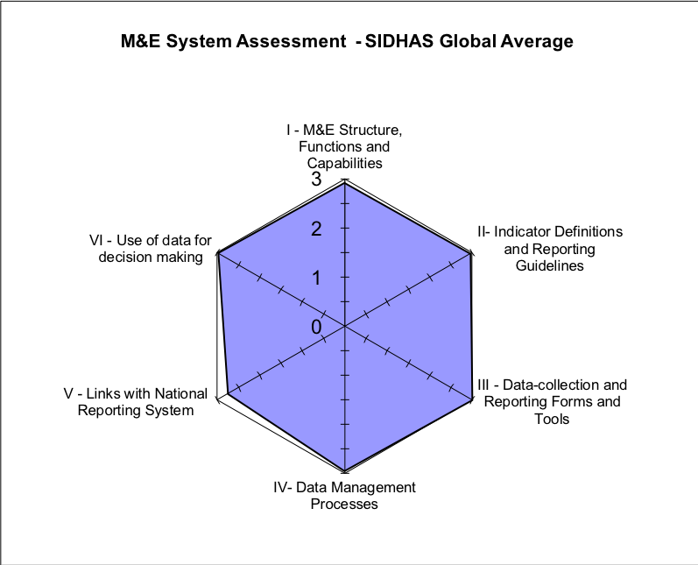

**Data Quality Standards**

Validity: Data validation findings from the PEPFAR IA team:

**HTS_TST**: The concurrence rates (CR) obtained for the indicator in all the sites fell within the acceptable variance of +/- five percent.

**PMTCT_STAT**: PMTCT_STAT data was only available in seven of the nine sites visited. LSMH and DLHMH are not PMTCT sites. Six of the seven sites had CR within the acceptable variance of +/- five percent and can be judged to have passed. EGH had a CR of 116.1 percent (fail).

**PMTCT_ART**: PMTCT_ART data was only available in seven of the nine sites visited. For the PMTCT_ART New disaggregate, six of the sites had CR of 100 percent (pass). UBTH significantly over-reported with a CR rate of 700 percent (fail). CR for the PMTCT_ART previously on ART disaggregate were 100 percent (pass) in six of the nine sites. EGH under-reported with a CR of 65 percent, which is not within the acceptable variance of +/- five percent and this site can be judged to have failed.

**TX_NEW**: Seven sites had a CR of 100 percent (pass) for the TX_NEW indicator. UBTH had a CR of 100.3 percent (pass). EGH had a CR of 116.4 percent (over-reporting) which falls outside the acceptable variance of +/- five percent and can be judged to have failed.

**TX_CURR**: The proportion of selected active folders validated correct by age was obtained in all the facilities. In IEPHC, UBPHC, DLHMH, UCTH and SPHC all the selected active folders reviewed were validated correct by age (100 percent). EGH, UBTH, UCH and LSMH had proportions of 101.3, 99.3, 98.1 and 99.3 percent respectively. The proportion of selected active folders validated correct by sex was 100 percent in eight health facilities. In SPHC, 98 percent of the folders were validated correct by sex. The proportion of selected active RADET entries validated active onsite was 100 percent in seven sites (EGH, IEPHC, LSMH, DLHMH, UCTH, UBTH, and SPHC). UBPHC and UCH had proportions of 98.3 and 96.3 percent respectively.

Qualitative findings from the PEPFAR IA team: The qualitative findings stated below were obtained only from the three health facilities in Akwa Ibom state that the MEL Activity DQA team visited. *Best* *Practices*: (1) Registers were properly filled (EGH and UBPHC); (2) Patients’ folders were well kept and in good condition; and (3) Good filing and retrieval system. *Areas for improvement:* (1) No Electronic Medical Record (EMR) available in the health facility (IEPHC); and (2) There was no clear evidence of patient tracking (IEPHC). *Recommendations:* (1) The central M&E unit should ensure the availability of a functional EMR in the IEPHC health facility; and (2) The M&E staff at IEPHC should ensure the proper and efficient tracking of patients.

Integrity: *Strengths* (1) Multiple dedicated staff conducting quality checks; (2) Validation rules in the DHIS2 which improve data quality; (3) Supervisory visits to health facilities; (4) Follow-up emails and phone calls to health facilities; (5) The use of the password-protected LAMIS and DHIS2; (6) Built-in checks in LAMIS and DHIS2 that prevent double counting; (7) Source documents and folders are kept in locked records rooms in the health facilities; and (8) Multiple data verification tools and processes to ensure data quality. *Areas for improvement*: (1) Designated staff not duly signing and dating MSFs (LSMH); and (2) Improper archiving of source documents in some health facilities. *Recommendations:* (1) Designated M&E should ensure all M&E tools are signed and dated at the end of every reporting month; and (2) Source documents and reporting tools should be archived appropriately according to the guidelines in the M&E SOP.

Precision*:* *Strengths*: Data elements in the primary and secondary source documents for the comprehensive HIV indicators have sufficient detail, therefore ensuring that the data has enough precision for programmatic decision-making. *Areas for improvement*: None. *Recommendations:* None.

Reliability: *Strengths*: Uniform use of the same reporting platforms in the states and health facilities. *Areas for improvement:* The use of outdated ART registers in LSMH. *Recommendations:* Ensure the usage of newly revised ART registers at LSMH.

Timeliness: *Strengths*: Clearly defined timelines for data reporting at all levels of the IP to the Government of Nigeria (GoN) and to USAID. *Areas for improvement:* None. *Recommendations:* None.

## 1.3 CONCLUSION

With reference to the ADS 201 definition of data quality standards, data reported by SIDHAS for the TX_CURR, TX_NEW, HTS_TST, PMTCT_STAT, PMTCT_ART and PMTCT_EID indicators were found to be valid, reliable, precise and have integrity. Reliability can be improved by the use of the new revised nationally approved ART register in LSMH. Integrity can also be improved by ensuring that all M&E tools are signed and dated at the end of every reporting month by designated staff and source documents and reporting tools are archived appropriately in the health facilities.

The results from the PEPFAR IA showed that all nine sites visited passed for the HTS_TST indicator. For PMTCT_STAT, six sites passed and one site failed. UBTH had a significantly high CR of 700 percent for PMTCT_ART New disaggregate while the other six sites passed. Six sites passed while one site (EGH) failed for the previously on ART disaggregate. Eight sites passed and one site (EGH) failed for TX_NEW. In all nine sites, the proportions obtained for the TX_CURR validation all fell within the acceptable variance range.

# Introduction and purpose of the DQA

Nigeria has the second largest number of people living with the Human Immunodeficiency Virus (HIV) globally and accounts for nine percent of the global HIV burden. The United States Government (USG), through the U.S. President’s Emergency Plan for AIDS Relief (PEPFAR), currently assists more than 600,000 Nigerians with life-saving HIV therapy, which is 90 percent of the people living with Human Immunodeficiency Virus/Acquired Immunodeficiency Syndrome (HIV/AIDS) in Nigeria. Activities focus on expanding programs that prevent transmission to the most-at-risk populations, while also stopping the high rate of mother-to-child transmission. More than one million children orphaned and made vulnerable by HIV, receive care and support through these programs. PEPFAR Nigeria supports comprehensive treatment through a number of partners and community-based organizations (CBOs) that work directly with the communities. Performance results are reported semi-annually based on the Office of the Global AIDS Coordinator (OGAC) requirements, and quarterly based on United States Agency for International Development (USAID) requirements.

USAID/Nigeria's technical offices regularly collect performance data from their IPs and analyze it to make management decisions. Program management requires accurate, reliable, complete, and timely data to facilitate evidence-based decision-making and, ultimately, to ensure efficient and effective program implementation. Programs targeted at populations that are affected by HIV/AIDS provide prevention, care and treatment services in order to improve their quality of life. The programs are both live-saving and resource intensive (capital and human). Therefore, these programs require data that ensure that high-quality services are provided to these affected populations, especially women and children who are most affected by the deadly virus. Since poor-quality data could affect conclusions about performance and lead to incorrect decisions, USAID requires that all Missions/Offices conduct regular Data Quality Assessments (DQAs).

The Automated Directives System (ADS) contains the organization and functions of USAID, along with the policies and procedures that guide the Agency's programs and operations. As shown in ADS 201, the purpose of a DQA is to ensure that USAID Missions are aware of the:

1. Strengths and weaknesses of the data, as determined by applying the five data quality standards (Table 1 below); and
2. Extent to which the data integrity can be trusted in making management decisions (ADS 201.3.5.8).

One of the primary purposes of the DQA described in this report is to meet the ADS-related requirements of USAID/Washington and the USAID/Nigeria technical offices. A DQA also serves to review the Monitoring and Evaluation (M&E) system, identify best practices, and develop recommendations to improve existing systems, for better reporting of activity level indicators in subsequent funding cycles.

In June 2018, USAID/Nigeria and the Monitoring, Evaluation and Learning (MEL) Activity of DevTech Systems, Inc. conducted a joint DQA to assess the Monitoring and Evaluation (M&E) system being used to generate and report data by the Strengthening Integrated Delivery of HIV/AIDS Services (SIDHAS) Activity, one of USAID/Nigeria’s Implementing Mechanisms (IMs) implementing HIV prevention, care and treatment activities. The DQA team assessed six PEPFAR indicators: **HTS_TST, PMTCT_ART, PMTCT_EID, PMTCT_STAT, TX_CURR, and TX_NEW.** These six indicators are reported through the USG District Health Information System (DHIS) 2.0 Data Accountability, Transparency and Impact (DATIM) platform. The period of the assessment was six months, October 1, 2017 to March 31, 2018, which is the Fiscal Year (FY) 2018’s Semi Annual Program Results (SAPR) reporting period.

In the months of May and June 2018, a separate team of assessors comprising of PEPFAR Interagency (IA) staff, conducted a data validation exercise for five of the six indicators (**HTS_TST, PMTCT_ART, PMTCT_STAT, TX_CURR** and **TX_NEW).** The **PMTCT_EID** indicator was **not** assessed by the PEPFAR IA team. The MEL Activity DQA team therefore focused only on the M&E systems assessment of the SIDHAS IM. The data validation results from the IA exercise for the sites visited by the MEL Activity DQA team have been incorporated into this report to compliment the results of the M&E systems assessment conducted the MEL Activity DQA team.

Using a purposive sampling methodology and with guidance from USAID, the MEL Activity team selected and visited nine health facilities in four states (Edo, Cross River, Lagos and Akwa Ibom), the respective SIDHAS state offices, and the SIDHAS central M&E unit in Abuja.

## 2.1 DATA QUALITY STANDARDS

Table 1 lists the five data quality standards that are central to a DQA, especially in the context of USAID-funded activities.

Table 1. Data Quality Standards and Operational Definitions

|  |  |
| --- | --- |
| **Data Quality Standard** | **Operational Definition** |
| **Validity** | Data are valid to the extent that they clearly, directly and adequately represent the result that was intended to be measured. Measurement errors, unrepresentative sampling and simple transcription errors may adversely affect data validity. Data should be periodically tested to ensure that no error creates significant bias. |
| **Reliability** | Data reflect stable and consistent data collection processes and analysis methods over time. Activity managers are confident that progress toward performance targets reflects real changes rather than variations in data collection methods. Reliability can be affected by questionable validity as well as by changes in data collection processes. |
| **Timeliness** | Data are available with enough frequency and should be sufficiently current to inform management decision-making. Effective management decisions depend upon regular collection of up-to-date performance information. |
| **Precision** | Data should be sufficiently accurate to present a fair picture of performance and enable activity managers to make confident decisions. |
| **Integrity** | Data that are collected, analyzed and reported should have a mechanism in place to reduce the possibility that data are subject to erroneous or intentional alteration. |

Source: ADS 201. Data Quality Assessment Standards.

## 2.2 OBJECTIVES OF THE DQA

In addition to the overall purpose of the DQA mentioned in ADS 201.3.5.8, the specific objectives of the DQA are to:

* Verify that the quality of data reported by the SIDHAS IM are grounded in the components of data quality.
* Ensure that managers can use these data generated to effectively direct available resources and to evaluate progress towards established goals.
* Assess and identify potential challenges to data quality that the data management and reporting systems create at three levels:
  + The Activity’s Central M&E Unit;
  + The Intermediary Aggregation Level (State); and
  + The Service Delivery Sites (Healthcare facilities)
* To develop action plans to improve weaknesses identified in the levels above.

## 2.3 INDICATORS ASSESSED

Based on guidance from USAID/Nigeria, the MEL Activity DQA team assessed the following six PEPFAR comprehensive HIV indicators:

* **HTS_TST**: Number of individuals who received HIV Testing Services (HTS) and received their test results.
* **PMTCT_STAT**: Percentage of pregnant women with known HIV status at antenatal care (includes those who already knew their HIV status prior to Antenatal Care [ANC] visit).
* **PMTCT_EID**: Percentage of infants born to HIV-positive women who received a first virologic HIV test (sample collected) by 12 months of age.
* **PMTCT_ART**: Percentage of HIV-positive pregnant women who received ART to reduce the risk of mother-to-child-transmission (MTCT) during pregnancy
* **TX_NEW**: Number of adults and children newly enrolled on antiretroviral therapy (ART).
* **TX_CURR**: Number of adults and children currently receiving antiretroviral therapy (ART).

All six indicators are PEPFAR Monitoring, Evaluation and Reporting (MER) indicators, with a quarterly reporting timeframe. The Performance Indicator Reference Sheet (PIRS) for each of these indicators is contained in the PEPFAR MER 2.0 Indicator Reference Guide Version 2.2 and in the Annex section 8.2.

## 2.4 PERIOD OF THE DQA

The DQA covered the USAID SAPR reporting period, which comprises six months or two quarters—i.e., October 1, 2017 to December 31, 2017, and January 1, 2018 to March 31, 2018. The schedule for the DQA by state is shown in Table 2 below.

Table 2. Schedule for SIDHAS DQA, by State

|  |  |  |
| --- | --- | --- |
| **IM** | **Level** | **Date of DQA** |
| **SIDHAS** | Central Level DQA | 08 June 2018 |
| Aggregation and service delivery levels in Edo state | 11-12 June 2018 |
| Aggregation and service delivery levels in Cross River state | 13-14 June 2018 |
| Aggregation and service delivery levels in Akwa Ibom state | 25-27 June 2018 |
| Aggregation and service delivery levels in Lagos state | 26-27 June 2018 |

## 2.5 THE PEPFAR INTERAGENCY DATA VALIDATION EXERCISE

Since Fiscal Year (FY) 2014, Nigeria has adopted a tool called the Retention and Audit Determination Tool (RADET), which is used by its partners to generate and report data on current clients on treatment. This tool has greatly improved reporting on the TX_CURR indicator. This DQA initiative focuses on validating selected indicators that are critical in the care cascade on which the achievement of the UNAIDS 90-90-90 goal is premised, as well as validating the output from the RADET from which site level TX_CURR is reported in DATIM.

The PEPFAR Nigeria team instituted the RADET validation and DQA in FY15 and has conducted the exercise every year since then. Planning and execution of the exercise is carried out jointly as an IA activity involving all three agencies – USAID, the Centers for Disease Control and Prevention (CDC), and the US Department of Defense (DOD) – and the PEPFAR coordination office. The fourth round of the exercise was conducted in May and June 2018 by PEPFAR Nigeria to validate the FY 18 SAPR of funded comprehensive HIV/AIDS activities using selected indicators.

## 2.6 THE SIDHAS ACTIVITY

SIDHAS is a PEPFAR/USAID funded activity implemented by FHI 360. The goal of the activity is to sustain cross-sectional integration of HIV/AIDS and TB services in Nigeria by building Nigerian capacity to deliver sustainable high-quality, comprehensive prevention, treatment, care and related services. It is a follow-on to the USAID funded Global HIV/AIDS Initiative Nigeria (GHAIN) activity, which supported the Government of Nigeria’s (GoN) response to the HIV epidemic in Nigeria from 2004 to 2011 (Figure 2). The activity was initially implemented in 36 states and the Federal Capital Territory (FCT). In response to the current strategic direction of PEPFAR, it currently supports 749 health facilities and 28 CBOs across thirteen states: Adamawa, Akwa Ibom, Anambra, Bauchi, Bayelsa, Borno, Cross River, Edo, Jigawa, Kano, Lagos, Rivers, and Yobe (Figure 3). The geographic focus is on the HIV epidemic control in fourteen high-burden Local Government Areas (LGAs) in Akwa Ibom, Cross River, Lagos and Rivers. The period of performance for SIDHAS is October 2011 through September 2018, and the net benefit to the intended target audiences is uninterrupted access to sustainable, high quality HIV services and chronic care for clients needing the services in the thirteen implementation states.

Figure 2. Dovetailing of Activity Outcomes: GHAIN versus SIDHAS

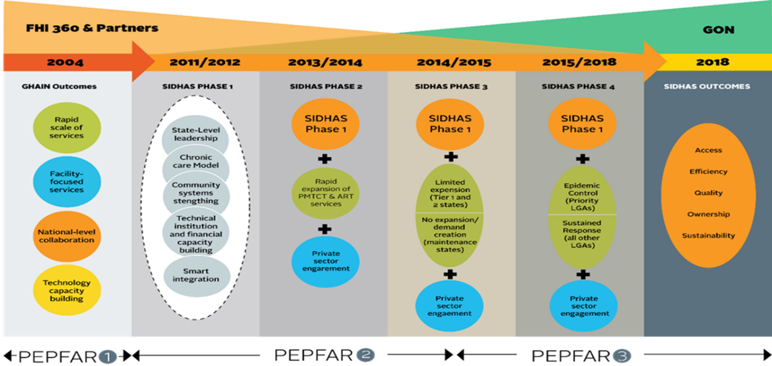

Figure 3. SIDHAS Coverage in Nigeria

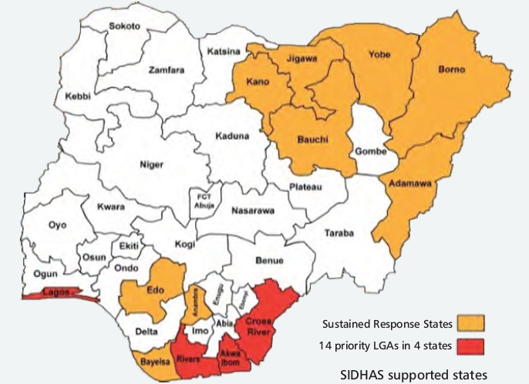

Using a number of implementation strategies, the activity will produce results in three key areas:

1. Increased access and improved coverage of high-quality, comprehensive HIV/AIDS and TB prevention, treatment and care services through improved efficiencies in service delivery;
2. Improved integration of high-quality HIV/AIDS and TB services across multiple sectors; and
3. Improved stewardship by Nigerian institutions for the provision of high-quality, comprehensive HIV/AIDS and TB services.

Family Health International (FHI) 360 is currently implementing SIDHAS in collaboration with five primary partners: Achieving Health Nigeria Initiative (integrated services); Association for Reproductive and Family Health (ARFH) (community-based services); Deloitte Consulting, LLP (organizational development); German Leprosy and Tuberculosis Relief Association (TB and HIV integration); and Howard University Pharmacists and Continuing Education Center (pharmacy services). Past partnerships included the Axios Foundation, (logistics and supply chain management), Population Council (community operations research for Prevention of Mother-to-Child Transmission [PMTCT]) and University of Nigeria (health economics operations research). In addition, the activity previously engaged two subcontractors, Hygeia Foundation and Health Systems Consult Limited, to support private-sector engagement in two states.

SIDHAS’ implementation strategy includes a combination of central, state, LGAs, health facility and community-level interventions and continuous quality improvement plans. These are designed to strengthen health systems and improve technical, financial and institutional management capacities for implementing sustainable high-quality facility-based HIV and AIDS service delivery.

# METHODOLOGY

## 3.1 SAMPLING METHODOLOGY FOR SITE SELECTION

For this DQA exercise, purposive sampling technique was employed for site selection. The selection criteria used are detailed below.

### INCLUSION CRITERIA

* Sites where USAID-supported comprehensive HIV activities are actively being implemented by SIDHAS;
* Sites which reported results for all of the six comprehensive HIV indicators for FY 2018 SAPR (October 1, 2017 – March 31, 2018);
* Sites selected to be visited during the FY 2018 PEPFAR inter-agency data validation exercise; and
* Sites within or in close proximity to the LGAs visited during the FY 2017 DQA exercise for the OVC_SERV indicator for STEER, SMILE and LOPIN 3 activities.

### EXCLUSION CRITERIA

* Sites located in high security level states, ranked at level four or for which access to the state requires passage through a level four state; and
* Sites located in a difficult, hard to reach terrain.

## 3.2 SAMPLE SIZE

The IP’s central office, four IP state offices (Akwa Ibom, Cross River, Edo and Lagos) and nine health facilities (service delivery sites) were selected based on the criteria outlined above and visited for the DQA exercise. These nine health facilities contributed **36 percent** to the TX_CURR data reported by SIDHAS for the FY 2018 SAPR. Table 3 below contains a list of selected sites, their state locations and shows the dates these sites were visited.

Table 3. List of all the sites visited and the dates of visit.

| **S. NO** | **LEVEL** | **NAME OF OFFICE/SITE** | **LOCATION** | **DATE OF VISIT** |
| --- | --- | --- | --- | --- |
| 1 | SIDHAS Central M&E Unit | SIDHAS Central Office | Abuja | June 8,2018 |
| 2 | Aggregation level | SIDHAS State Office | Edo | June 11,2018 |
| 3 | Service delivery level | University of Benin Teaching Hospital (UBTH) | Edo | June 11,2018 |
| 4 | Service delivery level | Uromi Central Hospital (UCH) | Edo | June 12, 2018 |
| 5 | Aggregation level | SIDHAS State Office | Cross River | June 13, 2018 |
| 6 | Service delivery level | University of Calabar Teaching Hospital (UCTH) | Cross River | June 13, 2018 |
| 7 | Service delivery level | Dr Lawrence Henshaw Memorial Hospital (DLHMH) | Cross River | June 14, 2018 |
| **8** | Aggregation level | SIDHAS State Office | Lagos | June 27, 2018 |
| **9** | Service delivery level | Lagos State Mainland Hospital (LSMH) | Lagos | June 26, 2018 |
| **10** | Service delivery level | Sango Primary Health Center (SPHC) | Lagos | June 27, 2018 |
| **11** | Aggregation level | SIDHAS State Office | Akwa Ibom | June 25, 2018 |
| **12** | Service delivery level | Etinan General Hospital (EGH) | Akwa Ibom | June 27, 2018 |
| **13** | Service delivery level | Uyo Base Primary Health Center (UBPHC) | Akwa Ibom | June 25, 2018 |
| **14** | Service delivery level | Ikot Ekpene Primary Health Center (IEPHC) | Akwa Ibom | June 26, 2018 |

A complete list of a personnel interviewed at various levels is provided in the Table 12 in the Annexes.

## 3.3 DQA PROCESS (MEL ACTIVITY DQA TEAM)

The DQA conducted by the MEL Activity DQA team included two processes:

* An M&E systems assessment; and
* Review of the five data quality standards; validity, reliability, integrity, precision, and timeliness.

The results of the FY 2018 PEPFAR IA data validation exercise was used to compliment the M&E systems assessment findings of five of the six indicators.

### 3.3.1 M&E SYSTEMS ASSESSMENT

The M&E systems assessment covered the following six functional areas for each of the six indicators:

* M&E structure, functions and capabilities;
* Indicator definitions and reporting guidelines;
* Data collection, reporting forms and tools;
* Data management processes;
* Links with the national reporting system; and
* Use of data for decision making.

The systems assessment was also administered at each level of data collection and reporting system including the central, intermediate (state level) and service delivery (health facility) level.

The M&E systems assessment process also involved:

* A desk review of activity documents, materials, and data, including: the organization’s standard operating procedures (SOP), guidelines, the Activity MEL plan, the PIRS for the six indicators, and other guiding documents for organizational M&E management, data management, and processing.
* Key Informant Interviews (KIIs) and Focus Groups Discussions (FGDs) with members of the M&E unit at each level of assessment.

### 3.3.2 APPLICATION OF THE FIVE DATA QUALITY STANDARDS

Each of the six indicators were reviewed across the inquiry lines within the standard USAID DQA checklist. This checklist is a tool intended to assist in assessing each of the five aspects of data quality and provide a convenient manner in which to document the DQA findings.

## 3.4 PEPFAR INTERAGENCY DATA VALIDATION EXERCISE METHODOLOGY

The PEPFAR IA exercise was conducted in selected comprehensive HIV sites located in states receiving PEPFAR support based on the selection criteria outlined in the protocol for the exercise. The sites assessed were selected using a mix of census and purposive sampling. Sites which met the inclusion and exclusion criteria were selected for assessment with an addition of purposive selection of some sites which passed and failed in previous IA DQA exercises. Only the PEPFAR supported health facilities where data are generated were visited. Central and state IP offices were not visited by the IA team; however, the IA team visited all the SIDHAS health facilities visited by the MEL Activity DQA team.

At the health facilities, the IA assessment team reviewed facility level registers and patient medical records/folders of HIV positive adults, pregnant women and children assessing HIV/AIDS services and/or interventions. To determine the number of and specific folders to be reviewed for validation of the RADET report, five percent of patients reported as active and five percent of patients reported as inactive in the FY18 SAPR RADET were randomly generated.

Assessors received data pulled from DATIM containing the reported values for each indicator and site by quarter. Validation for the selected indicators involved a recount of on-site records and comparing the totals with reported values in DATIM for FY18 quarter one and quarter two. Assessors also received the line list of randomly selected active and inactive client numbers from the RADET for each site. For each client number, assessors checked if the record is seen onsite, if the age reported in the RADET matched the age in the onsite record, if the sex reported in the RADET matched the on-site records and if the treatment status (active or inactive) matches the on-site records. Data validation concurrence rate (CR) was used to determine accuracy of recounted data in comparison with DATIM reported data for each indicator and site. CR was calculated using the formula:

Concurrence Rate (CR) = (Reported count at selected site / Validated count at selected site) x 100

A +/- five percent margin of error was deemed acceptable for each indicator and used to judge if a site passed or failed each indicator.

## 3.5 DQA TOOL

The MEL Activity DQA team used the following tools during the DQA exercise:

* MEASURE Evaluation Multi-Indicator Routine DQA Tool (2015)[3].
* USAID DQA checklist/tool[4].

The MEASURE Evaluation multi-indicator tool addressed the six functional areas of the M&E systems for the six indicators while the USAID DQA checklist/tool was used to assess the five data quality standards for each of the six indicators.

Three tools were used by the PEPFAR IA team during the data validation exercise including the:

* PEPFAR Nigeria DQA Tool for data validation;
* Summary Validation Tool for validation of TX_CURR by age and sex; and
* PEPFAR Nigeria DQA Site/IP Feedback Form.

At each site, the IA assessors used the ‘data validation tool’ to review the relevant registers and monthly summary forms to generate the actual achievement for the indicators and capture data. The ‘summary validation tool’ was used by the IA assessors to pre-select client folders to be examined at the facility using unique identifications (IDs). For each client, the assessor confirmed if that record was seen on-site, if the age reported in the RADET matched with the age in the on-site records, if the sex reported in the RADET matched with the sex in on-site records and if the treatment status (active or inactive) matched based on the on-site records. The IA team also noted best practices and areas for improvement. This information was collected using a ‘site/IP feedback form’.

## 3.6 DATA ANALYSIS

Qualitative data contained in the MEASURE Evaluation RDQA tool and the USAID DQA checklist describing the M&E system of the six indicators and the assessment findings based on the five data quality standards were analyzed manually. Microsoft Excel was used to analyze the IA data validation exercise results provided by the IA team for five of the six indicators.

## 3.7 OTHER OPERATIONAL CONSIDERATIONS FOR DQAS

In conducting DQAs, the focus is on the indicator, not on the IP or the IM. The DQA team assessed the indicators as a whole, including all component parts, among the various partners who collect data for the indicators. The level of consistency —whether different IPs collect and report the same indicator data when compared to one another—was also considered during the assessment.

During the desk review, the MEL Activity DQA team examined the PEPFAR MER 2.0 indicator reference guide, which contains the PIRS for the indicators. The team also reviewed key aspects about indicator data quality before the site visits. When the DQA team met with the SIDHAS team, the DQA team assessed the PIRS for both indicators contained in the SIDHAS Activity MEL plan. The DQA team obtained information from the SIDHAS team regarding their definition of the indicators, methodology used to collect indicator data, and other questions to confirm if the team at the SIDHAS units understood the indicators as USAID intended each indicator to be understood. The DQA team also asked the SIDHAS team whether they had a PIRS for the indicators and compared it to the USAID Mission’s “master” PIRS (PEPFAR MER 2.0 indicator reference guide). This was to ensure a match, and to determine if customizations might affect the data, or were just specifications to add clarity and detail pertaining to SIDHAS and did not alter the consistency of the data. Documentation in the PIRS includes any limitations to the data, a determination of whether the data are deemed to be of sufficient quality to be reported externally, any migration or other plans of action needed (including more frequent DQAs), as well as the expected date of the next DQA.

During the field work, in order to allay initial apprehensions of the IP and their staff, the MEL Activity DQA team emphasized to the IP that a Data Quality Assessment differs from a Data Quality Audit, although both are abbreviated in the same manner (through the acronym DQA). The team also highlighted the intention to use the DQA results as a ‘learning tool’ for USAID and the IP to work together to resolve any data quality After field-based work, the DQA team debriefed the IP of preliminary DQA findings using a feedback form. Depending on the inconsistencies and/or areas for improvement identified, the team provided feedback and solutions, mitigating actions, and, as appropriate, solicitation of suggestions from the IP and USAID.

# FINDINGS

## 4.1 M&E SYSTEMS ASSESSMENT – SIX FUNCTIONAL AREAS

### SIDHAS CENTRAL M&E UNIT

#### M&E STRUCTURE, FUNCTIONS, AND CAPABILITIES

The central M&E unit has a well-documented organogram. All new M&E staff receive comprehensive training and orientation in data management, collection and reporting processes. Annual trainings are regularly provided for the staff of the unit. Refresher trainings are conducted whenever the data reporting tools are revised or new tools are developed. The DQA team sighted a spreadsheet containing a comprehensive training plan, which included designated SIDHAS staff across various program areas. A data flow structure showing the staff responsible for reviewing reports at each level prior to submission to the next level was sighted in the SIDHAS M&E SOP. Designated staff responsible for reviewing data quality were also clearly mentioned within the SOP. Feedback on reports is provided monthly to states, and supervisory visits to lower reporting levels are carried out on a quarterly basis. The DQA team was also able to sight trip reports of previous supervisory site visits from the central M&E unit to the states.

#### INDICATOR DEFINITION AND REPORTING GUIDELINES

The central M&E unit has a copy of the PIRS, the PEPFAR MER Indicator Reference Guide version 2.2, on the indicators being assessed and has shared it with all relevant levels in its reporting system. The SIDHAS activity also has an indicator dictionary which has been disseminated to all the reporting levels. Embedded in the indicator dictionary, is the description of services for each indicator along with the source documents, reporting time and procedure for reporting each indicator.

#### DATA COLLECTION AND REPORTING FORMS AND TOOLS

The central M&E unit utilizes the up-to-date national harmonized tools for data collection and reporting. The instructions on how to fill these tools are provided on the first page of the tools. All reporting units are advised to always read the instructions before completing the forms. The M&E SOP has precise instructions on how the data collection tools should be used. Data aggregation, analysis and manipulation steps are clearly described within the M&E SOP.

#### DATA MANAGEMENT PROCESSES

State M&E units report aggregate data from the Monthly Summary Forms (MSFs) submitted by the health facilities into the FHI 360 instance of the DHIS2. Data from the sub-national reporting levels are extracted by the central unit from the DHIS2 and reported to USAID in DATIM. The SIDHAS activity developed an internal software called DARS. It is an automated application used to transform HTS (HIV Testing Services) data from the national MSFs and DHIS2 to fit the DATIM HTS requirements. Validity checks in the DHIS2 prevent data entry errors. Confidentiality is maintained in data collation, processing, and storage at the central level. Data back-up at the central level is cloud-based and is done monthly.

Within the SIDHAS M&E SOP, there are written guidelines for the lower reporting levels on requirements and deadlines for reporting, back- up procedures, archiving source documents and on the data Change Management Process (CMP). The CMP is in use to address incomplete or inaccurate and missing reports. Even though, SIDHAS has a written policy which states the storage period of source documents, adoption of this policy is subject to the presence or absence of already existing policies within the facilities.

#### LINKS WITH THE NATIONAL REPORTING SYSTEM

Standard national tools are used for data collection and reporting. Data is reported from the IP central M&E office to the Government of Nigeria (GoN) and USAID. The system records information about where the service is delivered using standard national naming conventions (e.g., state code and name of LGA). Attempts are made by the central M&E unit to harmonize data at the quarterly National Agency for the Control of AIDS (NACA) data review meetings.

#### USE OF DATA FOR DECISION MAKING

The central M&E unit prepares charts and graphs using data for presentation and discussions at internal Data Review Meetings (DRMs). The DQA team sighted charts from previously conducted DRMs. The central M&E unit also provides guidance to sub-reporting levels beyond routine reporting, as evidenced by templates on DRM presentation shared with state offices. The central M&E unit also disseminates data to stakeholders in a timely manner. Evidence of analyzed data which informed program decisions include the use of a family centered treatment approach at option B+ sites so that men and children can access treatment.

Figure 4 below shows the spider graph of the SIDHAS central level M&E systems assessment, showing deficiencies only in the links with the national reporting system.

Figure 4. Spider chart of the SIDHAS Central Level M&E Systems Assessment

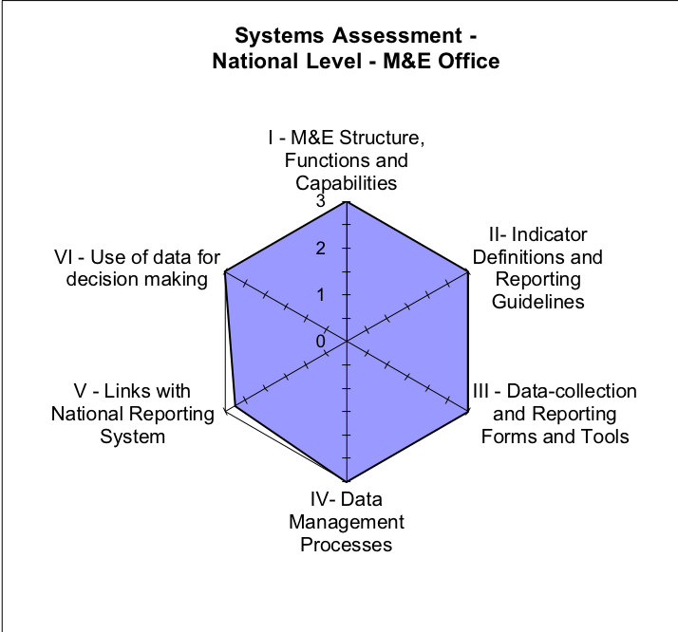

#### STRENGTHS – SIDHAS CENTRAL M&E UNIT

* Availability of trained M&E staff at the SIDHAS central M&E unit.
* Use of an internally developed software (DARS) to analyze and transform data into DATIM requirements.
* Availability and use of a detailed M&E SOP which includes clear steps for data aggregation, quality checks and data management processes.
* Feedback is provided to states when data discrepancies are observed.
* The use of a SIDHAS indicator dictionary at all levels of the IP.

#### AREAS FOR IMPROVEMENT – SIDHAS CENTRAL M&E UNIT

* The DQA team did not identify any major areas for improvement; however, the links to the national reporting system are an area that could be improved on a system-wide basis.

#### RECOMMENDATIONS – SIDHAS CENTRAL M&E UNIT

* Continue to maintain a high-quality M&E system.

### SIDHAS STATE-LEVEL M&E SYSTEM

#### M&E STRUCTURE, FUNCTIONS, AND CAPABILITIES

All the M&E staff at the state level reported to have received appropriate training on data management processes and tools. Training manuals and attendance sheets were seen in Edo and Cross River states. Designated staff responsible for reviewing the data differed between all four states as detailed in Table 4 below.

Table 4. Designated staff responsible for reviewing data at the SIDHAS State Level

|  |  |  |  |  |
| --- | --- | --- | --- | --- |
| **Tasks/States** | **Cross River** | **Edo** | **Akwa Ibom** | **Lagos** |
| **Staff responsible for reviewing report prior to submission** | M&E Officer | State Program Officer | Senior Technical Officer M&E | All M&E Staff |
| **Staff responsible for reviewing report from lower levels** | M&E Officer | Technical Officer | Senior Technical Officer M&E | Facility M&E backstop |

All states had a staff leave back-stopping plan to cater for instances when staff are not available. It was also emphasized that the M&E unit functions using a teamwork approach such that staff find it easy to assume the responsibilities of others who are temporarily unavailable.

Feedback from the central M&E unit on reported data is received via emails and regular supervisory visits, while feedback to the health facilities on reported data is provided:

* During review meetings;
* Through a ‘Continuous Quality Improvement and Technical Assistance (CQI/TA) form’ used to monitor progress at the facilities; and
* During monthly supervisory visits to the facilities.

#### INDICATOR DEFINITION AND REPORTING GUIDELINES

The PEPFAR MER Indicator Reference Guide version 2.2 and the SIDHAS indicator dictionary, which contain guidance on the content of services related to each indicator were seen in all four states. The SIDHAS “SOP for Routine Data Collection and Management” was also available in all of the states visited. The SOP contains a data flow chart which shows reporting timelines for reports due the central level M&E unit and the GoN.

#### DATA COLLECTION AND REPORTING FORMS AND TOOLS

All four SIDHAS state offices and the heath facilities within them utilize the same standard national tools and forms which have clear instructions on how to complete them on the first page of the registers or MSFs. The data collection forms and reporting tools seen at the states were the most recent versions. The states also provide instructions to the health facilities on utilization of the tools. There was sufficient stock of reporting tools in the four state offices.

#### DATA MANAGEMENT PROCESSES

Data quality is ensured through the following processes:

* Dedicated staff to review the data in the MSFs before it is entered into the DHIS2;
* Post data entry verification of the data;
* Validation rules in the DHIS2; and
* The use of an ART calculator and HTS calculator to avoid double counting.

The M&E SOP has written guidelines to address late, incomplete, inaccurate and missing reports. A CMP is used in all the states to document data discrepancies and how they were resolved. Copies of filled CMP forms were seen in Cross River and Edo states. The M&E unit in Edo state have a CMP register which is signed off by both the facility staff and the state SIDHAS staff. All four states use external hard drives for data back-up and back-up is done weekly. An additional means of back-up in Edo state is the use of paper-based data back-up which is done monthly.

#### LINKS WITH THE NATIONAL REPORTING SYSTEM

National forms and reporting tools are used in all the states. The data generated on the indicators is reported to the State Agency for the Control of AIDS (SACA) monthly. States also enter activity data into the FHI 360 instance of the DHIS2. The DHIS2 records the place where service delivery occurs, and standardized naming conventions are used to report data.

#### USE OF DATA FOR DECISION-MAKING

Charts and graphs were seen by the DQA team in all the states visited. In Edo and Akwa Ibom, the Senior Technical Officer M&E is responsible for developing and interpreting these charts while in Cross River, the M&E Officer is responsible. No specific staff was assigned to develop these charts in Lagos State as it was stated that all the M&E staff were responsible.

Analyzed data is disseminated to stakeholders during monthly data review meetings. Examples of the use of analyzed data to inform programmatic decisions was seen in Cross River and Lagos. One such example is the viral load drive. This was created to drive service uptake of viral load testing in Lagos after analysis of data collected showed poor uptake.

Below are the spider graphs of the M&E systems assessment for Akwa Ibom, Cross River, Edo and Lagos state M&E units. In all four states, there were deficiencies in the links with national reporting system due to data being reported to both USAID through the IP central office and the GoN at both the state level.

Figure 5. SIDHAS M&E Systems Assessments state level: Akwa Ibom

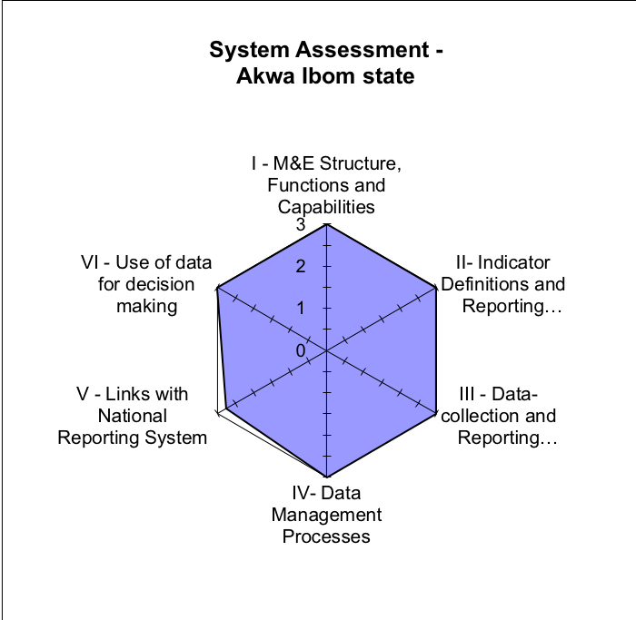

F*igure 6. SIDHAS M&E Systems Assessments state level: Cross River*

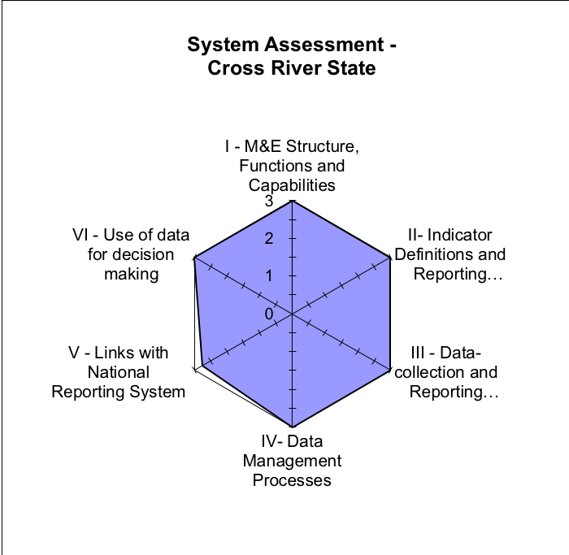

Figure 7. SIDHAS M&E Systems Assessments state level: Edo

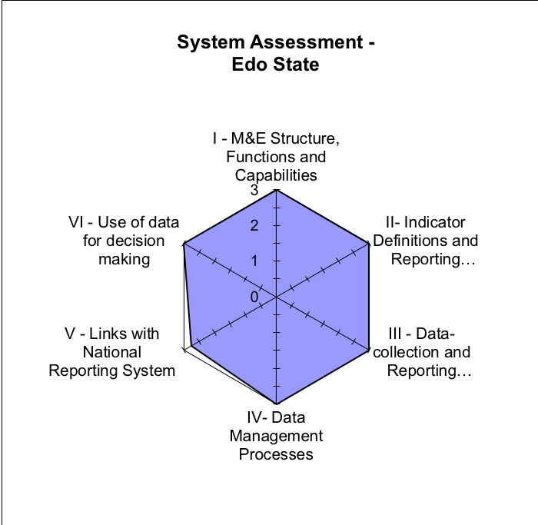

Figure 8. SIDHAS M&E Systems Assessments state level: Lagos

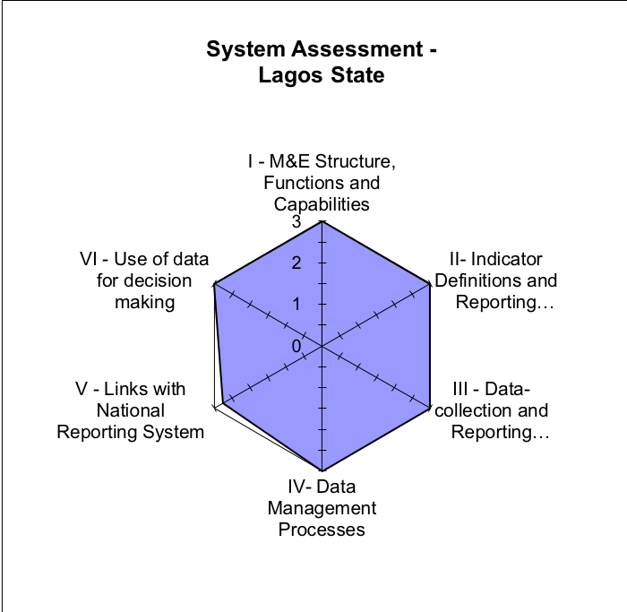

#### STRENGTHS - SIDHAS STATE LEVEL

* All state level M&E staff had a good level of understanding of the indicator definitions, data collection tools and reporting tools.
* The use of a CQI/TA form to provide feedback and track the progress of health facilities in resolving identified challenges.

#### AREAS FOR IMPROVEMENT - SIDHAS STATE LEVEL

* Infrequent visits from the state IP M&E staff to the health facilities in Edo.

#### RECOMMENDATIONS - SIDHAS STATE LEVEL

* State M&E staff in Edo should ensure that regular supervisory visits are made to the health facilities.

### SIDHAS SERVICE DELIVERY LEVEL (HEALTH FACILITIES)

Nine health facilities were visited by the DQA team. A comparative M&E systems assessment for these sites is presented below, with details of the specific functional areas.

#### M&E STRUCTURE, FUNCTIONS, AND CAPABILITIES

Staff of the health facilities have received appropriate training on the data management processes and tools. In six of the health facilities visited, the M&E staff received at least one training during the period under review. The M&E staff of DLHMH Calabar, UBTH Edo and UBPHC Akwa Ibom, did not receive any training during the period under review. In eight of the nine health facilities visited, the M&E Officer is responsible for reviewing the data before it is submitted to the SIDHAS state M&E unit. The Data Entry Clerk (DEC) is responsible for this task at UCH Edo. The M&E staff at the health facilities work as teams and can stand in for each other when required.

Feedback from the state offices on the quality of submitted reports is received through emails, phone calls, text messages, at monthly data review meetings and through the CQI/TA forms.

The health facilities reported regular monthly supervisory visits (daily visits in UCTH, Cross River) from the state offices. Documentation of site visits was sighted in three health facilities (EGH and IEPHC in Akwa Ibom, and SPHC in Lagos). However, it was observed that the two facilities in Edo state had not received any supervisory visits from the state office in the last three months.

#### INDICATOR DEFINITION AND REPORTING GUIDELINES

The SIDHAS dictionary and PEPFAR MER Indicator Reference Sheet version 2.2 were available in seven of the nine sites visited. The facilities in Edo did not have the SIDHAS dictionary which contains guidelines on collecting the content of each indicator. The SOP has guidelines on reporting requirements and timelines, archiving and storage of activity data and was available at all nine sites. The comprehensive HIV indicators are clearly understood by all relevant staff of the health facilities in the four states.

#### DATA COLLECTION AND REPORTING FORMS AND TOOLS

In all the health facilities, updated national harmonized tools were used for data collection and reporting. Clear instructions on completing the source documents and reporting forms are provided in the M&E SOP. The first page of all the registers in use contains instructions for filling the registers. There is also a LAMIS manual which includes instructions on entering data into the LAMIS, a copy of it was seen in UBTH. All the health facilities had sufficient stock of reporting tools. At LSMH in Lagos, outdated ART registers were still in use even though the most up-to-date ART registers was available in the facilities.

#### DATA MANAGEMENT PROCESSES

The health facilities use an electronic medical record system; the Lafiya Health Management System (LAMIS), to record patient level data within the facilities. The LAMIS was developed to enhance patient management and monitoring. The software captures patient level medical records and information related to HIV care and treatment, TB treatment, screening for cancer of the cervix and cardiovascular disease monitoring. It is installed in computers within comprehensive health facilities (sites with that provide both PMTCT and other comprehensive HIV prevention, care and treatment services) which have the hardware to use the LAMIS. The DHIS2 is also installed in comprehensive health facilities with the required hardware. At the comprehensive sites, data are directly entered into the national DHIS2. Other health facilities report monthly to the state using hard copy MSFs.

The following processes are employed by the health facilities to ensure data quality and avoid double counting.

* The LAMIS has built-in validation checks which detect double counting.
* Each client has a unique identification number, this helps avoid double counting.
* Designated staff to manually verify the data (all nine health facilities).
* The use of RADET analyzer.
* Use of ART calculator (EGH and UBPHC).
* Triangulation between multiple data sources.
* Monthly DQA to validate reports between registers and summary forms (IEPHC and UBPHC in Akwa Ibom).

It was observed by the DQA team that varying methods of data back-up were being used by the health facilities visited. Four facilities (UBTH, UCH, EGH and DLHMH) back-up data using external hard drives. Data back-up is cloud based at UCTH and DLHMH in Cross River. UBPHC, IEPHC and SPHC have no specific method of data back-up.

The SIDHAS SOP which contains policies on archiving and retention of source documents and reporting tools was available in all the sites visited. In spite of this policy, the DQA team noticed that the source documents were not properly stored in UBTH and UCH. Used and obsolete source documents were also not properly archived in EGH and IEPHC.

#### LINKS WITH NATIONAL REPORTING SYSTEM

National harmonized tools are used for data collection and reporting at all the health facilities. Comprehensive health facilities have links to the national reporting system through data uploaded into the national DHIS2. The comprehensive health facilities also report data to their LGAs. The system clearly records information about where the services are rendered, using standardized naming conventions (e.g., the state, LGA and ward) and the unique ID code.

#### USE OF DATA FOR DECISION-MAKING

Charts and graphs were seen in all the sites visited at all health facilities. Specific designated staff were responsible for developing these charts in all the facilities except for DLHMH, were it was reported that all members of the M&E staff were responsible. Analyzed data from the health facilities is disseminated to stakeholders during monthly data review meetings with the SIDHAS state office, meetings with THE LGA Agency for the Control of AIDS (LACA) and other staff of the health facilities. Clear examples of the use of analyzed data to make programmatic decisions were provided at all the sites visited.

Figure 9 below shows the overall spider graph for the health facilities assessed. Areas of deficit were identified in five of the six M&E functional areas.

Figure 9. SIDHAS Overall M&E Systems Assessments Health Facility Level

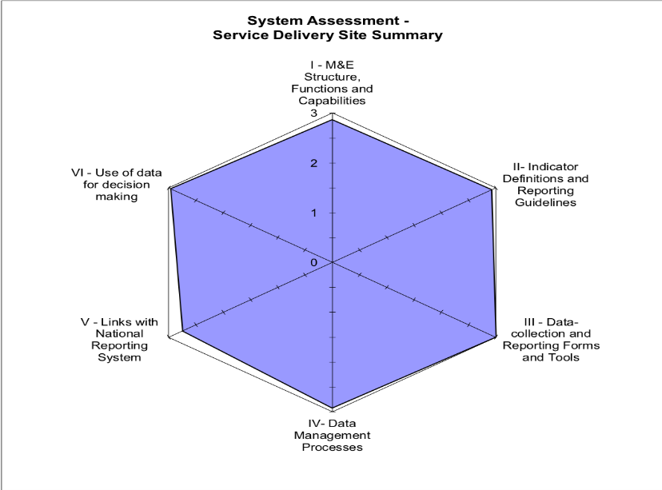

#### STRENGTHS

* M&E SOP was available in all the health facilities visited.
* M&E staff had a good understanding of the indicator definitions.
* The use of the LAMIS to record client level data and manage patients in the comprehensive HIV sites.
* Sufficient stock of blank data collection and reporting forms.
* Multiple data verification steps, tools and processes such as the ART calculator and the RADET analyzer to ensure data quality.
* Documents were well arranged and labelled according to thematic areas in fireproof cabinets (EGH).
* UBPHC has a performance monitoring dashboard that assists the facility to monitor individual indicator achievements and improvements.

#### AREAS FOR IMPROVEMENT

* No supervisory visits by the state IP to the health facilities in Edo state within the last three months.
* Absence of the SIDHAS indicator dictionary in the health facilities in Edo.
* Guidelines on back-up procedures were not fully in use by the health facilities, necessitating varying back-up methods.
* Inappropriate archiving of source documents in use in UBTH and IEPHC.
* Inadequate storage space for source documents in EGH and UCH, leading to improper archiving of these source documents and reporting tools.
* Outdated ART registers still in use at LSMH

#### RECOMMENDATIONS

* Edo state M&E staff should ensure that supervisory visits are made to the health facilities.
* The SIDHAS indicator dictionary should be provided to the health facilities in Edo.
* M&E staff at the health facilities should adhere to the guidelines on data back-up to ensure harmonization of the back-up processes at the health facilities.
* Ensure proper archiving of the source documents in use as well as used forms and registers according to the guidelines in the M&E SOP in UBTH and IEPHC.
* State M&E staff should undertake advocacy visits to the management of EGH and UCH to procure appropriate filing cabinets for archiving source documents.
* Current ART registers should be used to collect data in LSMH to ensure reliability of the data.

## 4..2 DATA QUALITY STANDARDS – SIDHAS

The data quality standards for SIDHAS are discussed below.

### 4.2.1 VALIDITY

Validity is the extent to which a measurement is well-founded and corresponds accurately to the real world. It pertains to measuring what is intended to be measured. Details of the review of data quality in the context of the comprehensive HIV indicators are provided below.

#### 4.2.1.1 UNDERSTANDING THE INDICATOR DEFINITIONS

**INDICATOR 1: HTS_TST**

Across the SIDHAS sites visited, this indicator measures the number of individuals who received HIV Testing Services (HTS) and received their test results. The numerator captures the number of individuals who received HTS and received their test results. The indicator has no denominator.

**INDICATOR 2: PMTCT_STAT**

Across the SIDHAS sites visited, this indicator is the percentage of pregnant women with known HIV status at ANC (includes those who already knew their HIV status prior to ANC). The numerator is the number of pregnant women with known HIV status at first antenatal care visit (ANC1). It includes those who already knew their HIV status prior to ANC1. The denominator is the number of new ANC clients in the reporting period.

**INDICATOR 3: PMTCT_ART**

Across the SIDHAS sites visited, this indicator is the percentage of HIV-positive pregnant women who received ART to reduce the risk of mother-to-child transmission (MTCT) during pregnancy. The numerator is the number of HIV-positive pregnant women who received ART to reduce the risk of mother-to-child transmission during pregnancy. The denominator is not collected as part of the indicator but is calculated as another indicator PMTCT_STAT_POS (Number of HIV positive pregnant women).

**INDICATOR 4: PMTCT_EID**

Across the SIDHAS sites visited, data collected for this indicator measures the percentage of infants born to HIV-positive women who received a first virologic HIV test (sample collected) by 12 months of age. The numerator is the number of infants who had a first virologic HIV test (sample collected) by 12 months of age during the reporting period. The denominator is not collected as part of the indicator, but is calculated as another indicator PMTCT_STAT_POS.

**INDICATOR 5: TX_NEW**

It measures the number of adults and children newly enrolled on antiretroviral therapy (ART). The indicator measures the ongoing scale-up and uptake of ART programs.

**INDICATOR 6: TX_CURR**

It measures the number of adults and children currently receiving ART. The current on ART count should equal the number of adults and children with HIV infection who ever started ART minus those patients who are not currently on treatment at the end of the reporting period.

The PEPFAR MER Indicator Reference Guide 2.2 was available and the M&E Staff were conversant with it at all reporting levels of the IP visited.

Table 5. Data Sources for the Comprehensive HIV Indicators

|  |  |
| --- | --- |
| **INDICATORS** | **DATA SOURCES** |
| **HTS_TST** | Client Intake Form, HTS Register, National HTS MSF and National PMTCT MSF |
| **PMTCT_ART** | PMTCT_ART Register and National PMTCT MSF |
| **PMTCT_STAT** | ANC Register and National PMTCT MSF |
| **PMTCT_EID** | Child Follow-up Register and National PMTCT MSF |
| **TX_CURR** | ART Care Card, ART Register and National ART MSF |
| **TX_NEW** | ART Care Card, ART Register and National ART MSF |

#### 4.2.1.2 DATA COLLECTION AND REPORTING

The source documents for the six indicators are listed in Table 5. Heath care workers enter the data into the primary source documents (PSDs) and secondary source documents (SSDs). DECs/Health facility staff then populate the MSFs using the information in the collated data in the SSDs which are then submitted to the SIDHAS state office. In facilities with the LAMIS, DECs enter the collated data into the platform. Facility M&E Officers or Heads of Department (HODs) review the data in the MSFs before submission to the state. State M&E staff enter the collated data from the health facilities and LGAs into the FHI 360 instance of DHIS. Finally, the central M&E unit reviews and submits the aggregated IP data to USAID through DATIM.

#### 4.2.1.3 DOES THE INFORMATION COLLECTED MEASURE WHAT IT IS SUPPOSED TO MEASURE?

All the indicators for SIDHAS match the PEPFAR MER indicator reference guide. They are direct measurements by definition and data collected is in accordance with the PIRS.

#### 4.2.1.4 STORAGE OF DATA

Following data entry into the source documents and subsequently into the LAMIS, DHIS2 and MSF, client folders are stored in filing cabinets, utilizing an alphanumeric system to ensure easy retrieval. Back-up of the soft copy of activity data is done using diverse methods in all the health facilities visited, including cloud-based storage, external hard drive and emails.

#### 4.2.1.5 DATA VALIDATION BY THE PEPFAR INTER-AGENCY EXERCISE

Data validation was conducted for five of the indicators by the PEPFAR IA team. The findings are discussed below.

**INDICATOR 1: HTS_TST**

The CR obtained for the indicator in all the sites fell within the acceptable variance of +/- five percent. UBPHC, IEPHC and UCTH had CR of 100 percent. However, as shown in Figure 10, EGH and LSMH over-reported while DLHMH, UBTH, UCH, and SPHC slightly under-reported. Therefore, all nine sites could be said to have passed.

Figure 10. Concurrence Rates for HTS_TST in the Health Facilities.

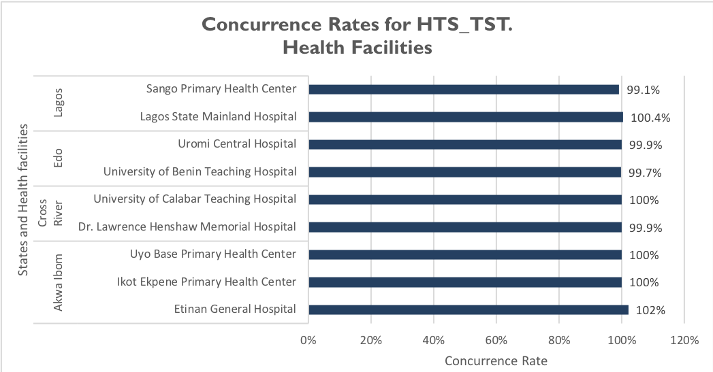

**INDICATOR 2: PMTCT_STAT**

PMTCT_STAT data was only available in seven of the nine sites visited. LSMH and DLHMH are not PMTCT sites, hence do not provide PMTCT services nor report PMTCT data. Four sites (IEPHC, UBPHC, UBTH and SPHC) had CR rates of 100 percent. UCH slightly under-reported while EGH over-reported as shown in Figure 11. Six of the seven sites had CR within the acceptable variance of +/- five percent and can be judged to have passed. EGH had a CR of 116.1 percent (fail).

Figure 11. Concurrence Rates for PMTCT_STAT in the Health Facilities.

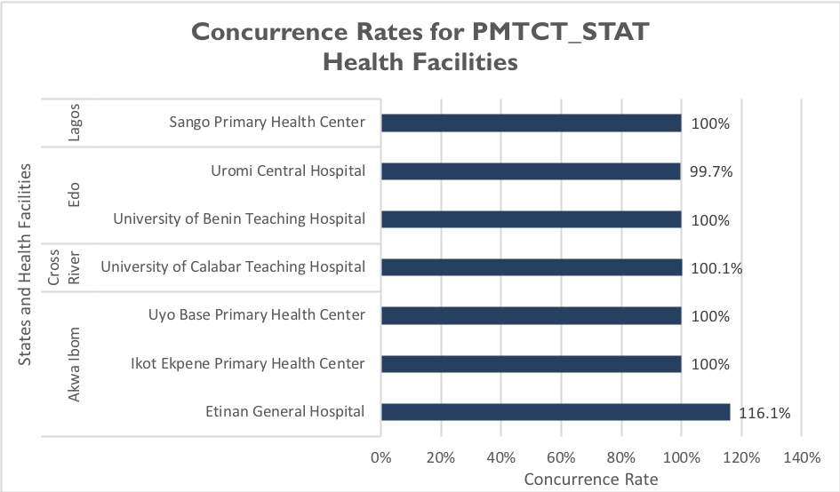

**INDICATOR 3: PMTCT_ART**

This indicator has two disaggregates; ‘New on ART’ and ‘Already on ART’ at the beginning of the current pregnancy. Each disaggregate was validated individually. PMTCT_ART data was only available in seven of the nine sites visited. For the PMTCT_ART New disaggregate, six of the sites had CR of 100 percent (pass) as depicted in Figure 12. UBTH over-reported significantly with a CR of 700 percent (fail).

Figure 12. Concurrence Rates for PMTCT_ART New Disaggregate in the Health Facilities.

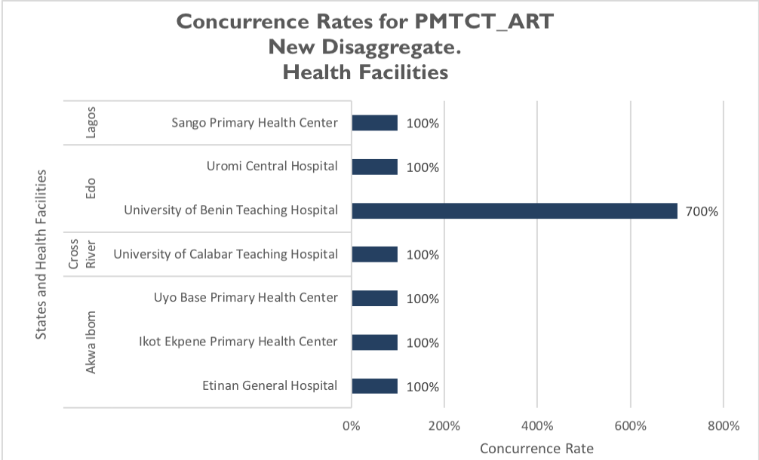

CR for the PMTCT_ART previously on ART disaggregate (Figure 13) were 100 percent (pass) in six of the sites. EGH under-reported with a CR of 65 percent which is not within the acceptable variance of +/- five percent and this site can be judged to have failed.

Figure 13. Concurrence Rates for PMTCT_ART Previously on ART Disaggregate in the Health Facilities.

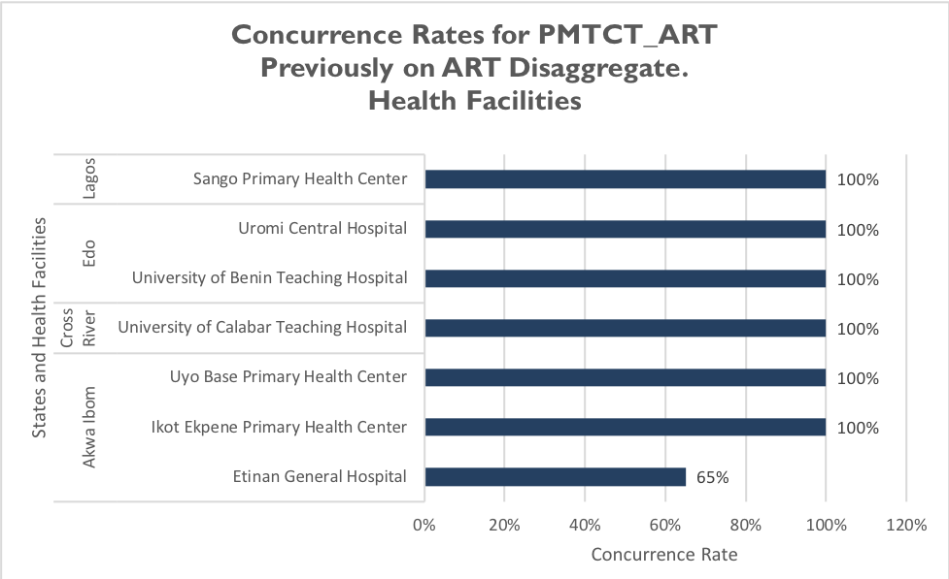

**INDICATOR 4: TX_NEW**

All nine sites had data on TX_NEW indicator validation. Seven sites had a CR of 100 percent for the indicator (pass). UBTH had a CR of 100.3 percent (pass). EGH had a CR of 116.4 percent (over-reporting) which falls outside the acceptable variance of +/- five percent and can be judged to have failed. Figure 14 shows the CR for TX_NEW in the health facilities.

Figure 14. Concurrence Rates for TX_NEW in the Health Facilities.

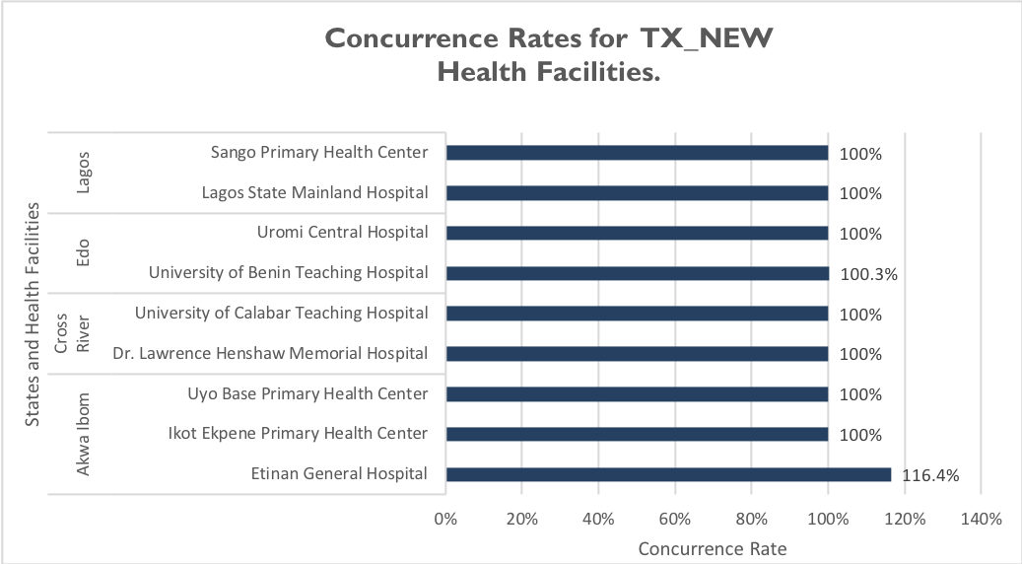

**INDICATOR 5: TX_CURR**

Active TX_CURR was validated in three ways. First, by determining the proportion of selected active folders validated correct by age. Second, by determining the proportion of selected active folders validated correct by sex and finally, by calculating the proportion of selected active RADET entries validated active onsite. The proportion of selected active folders validated correct by age was obtained in all nine facilities. In IEPHC, UBPHC, DLHMH, UCTH and SPHC all the selected active folders reviewed were validated correct by age (100 percent) as seen in Figure 15. EGH, UBTH, UCH and LSMH had proportions of 101.3, 99.3, 98.1 and 99.3 percent respectively.

Figure 15. Proportion of Selected Active Folders Validated Correct by Age, TX_CURR

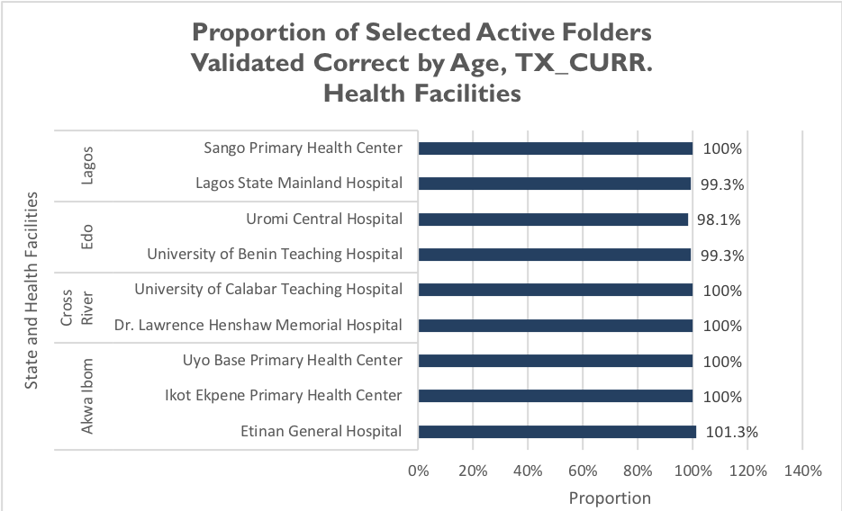

The proportion of selected active folders validated correct by sex was 100 percent in eight health facilities as shown in Figure 16. In SPHC, 98 percent of the folders were validated correct by sex.

Figure 16. Proportion of Selected Active Folders Validated Correct by Sex, TX_CURR

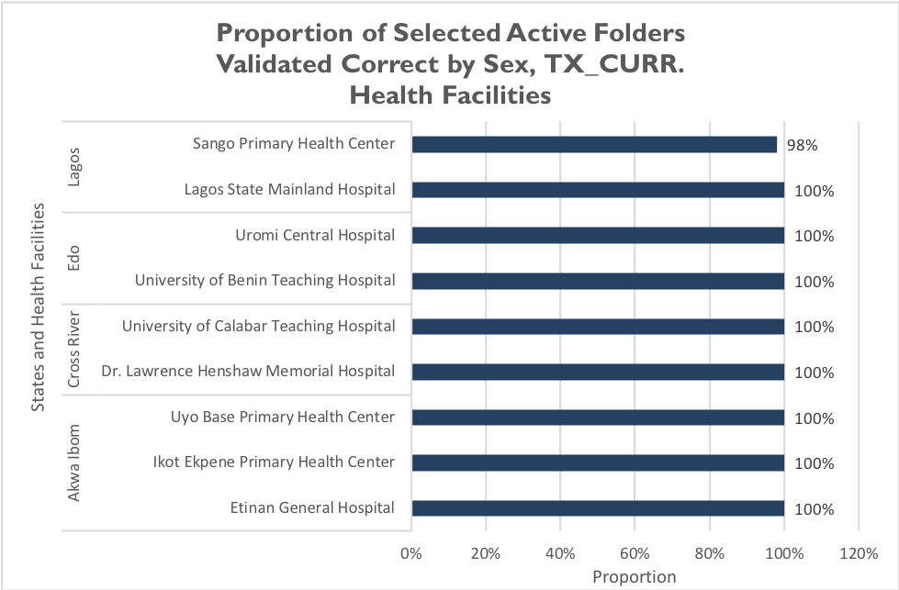

The proportion of selected active RADET entries validated active onsite was 100 percent in seven sites (EGH, IEPHC, DLHMH, UCTH, UBTH, LSMH and SPHC). UBPHC and UCH had proportions of 98.3 and 96.3 percent respectively as shown in Figure 17.

Figure 17. Proportion of Selected Active RADET Entries Validated Active On-site, TX_CURR

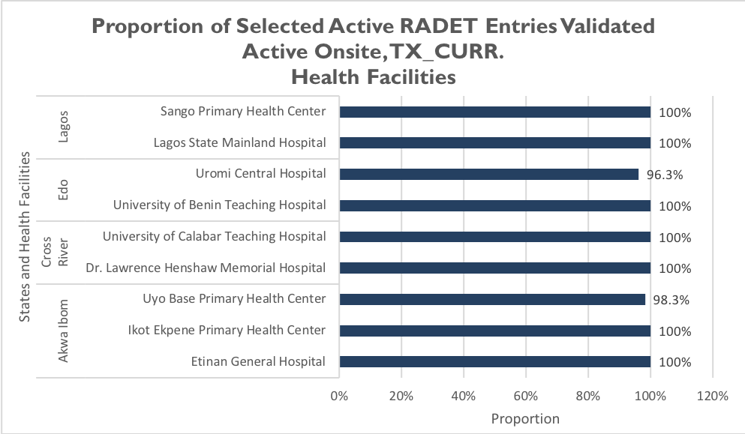

The inactive folders and entries were available for validation in the nine sites visited. In eight health facilities, the proportion of inactive clients' folders seen onsite was 100 percent. In UCTH, 98 percent of the inactive clients’ folders were seen onsite (Figure 18). The selected RADET inactive clients’ folders were 100 percent validated as inactive onsite in eight of the sites (Figure 19).

Figure 18. Proportion of Inactive Clients' Folders seen Onsite, TX_CURR

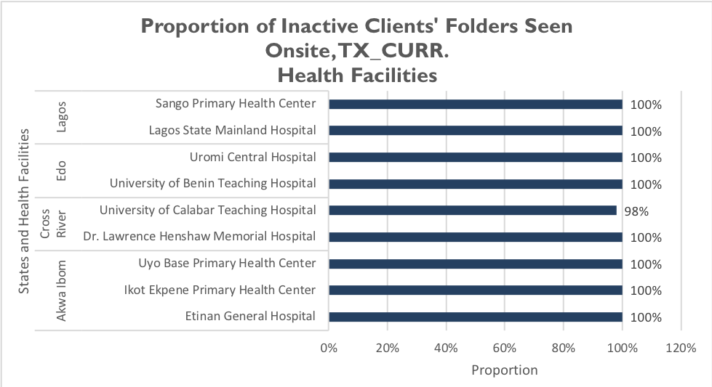

Figure 19. Proportion of Inactive Clients' Validated as Inactive Onsite, TX_CURR

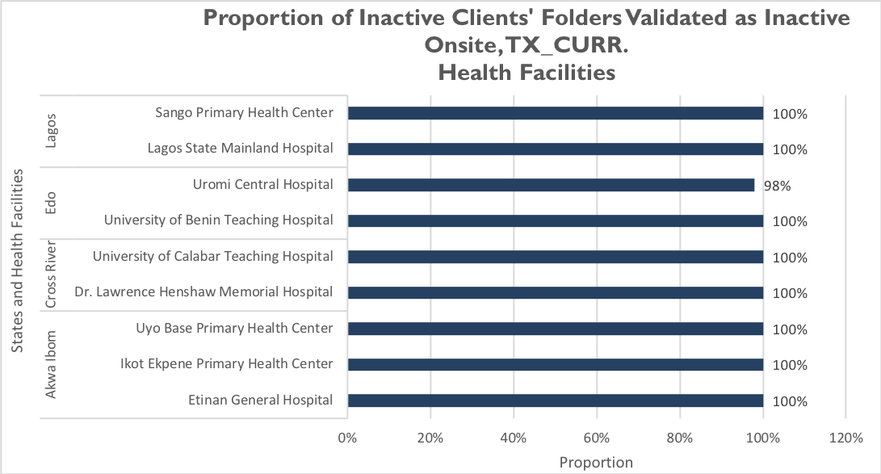

Table 6 below shows the CR for the HTS_TST, PMTCT_STAT, PMTCT_ART and TX_NEW indicators across the nine health facilities. The CRs shaded red are outside the acceptable variance of +/- five percent while those shaded green are within the acceptable range.

Table 6. Concurrence Rates for FHI 360 SIDHAS Sites for HTS_TST, PMTCT_STAT, PMTCT_ART and TX_NEW



Table 7 below is a summary of the validation results for TX_CURR in the nine health facilities.

Table 7. Validation Results for TX_CURR for FHI 360 SIDHAS Sites



#### 4.2.1.6 QUALITATIVE FINDINGS FROM THE PEPFAR INTERAGENCY EXERCISE

The qualitative findings discussed below were obtained from three health facilities (EGH, UBPHC, IEPHC) in Akwa Ibom state.

Best Practices:

* Registers were properly filled (EGH, UBPHC).
* Patients folders were well kept and in good condition.
* Good filing and retrieval system.

Areas for Improvement:

* No Electronic Medical Record (EMR) available in the health facility (IEPHC).
* There was no clear evidence of patient tracking (IEPHC).

Recommendations:

* The central M&E unit should ensure availability of a functional EMR in the IEPHC health facility
* The M&E staff at IEPHC should ensure proper and efficient tracking of patients.

### 4.2.2. INTEGRITY

#### 4.2.2.1 MECHANISMS TO ENSURE DATA INTEGRITY

SIDHAS data collection and management process at the central IP level is through the DHIS2. Built-in validation checks in DHIS2 ensure data quality and maintain the integrity of the data. Data validation processes executed by its M&E team ensure that the data collated by SIDHAS undergoes multiple data quality checks. Other mechanisms in place at the central level to ensure the integrity of the data include built-in checks in DHIS2 that prevent double entries, feedback to the sub-national reporting systems via phone calls and emails and conduct of supervisory visits to lower reporting levels.

At the state level, SIDHAS M&E Officers conduct data quality checks on data before and after the data is entered into the DHIS2 to ensure confidentiality. Further mechanisms to ensure data integrity include dedicated staff to check data quality, supervisory visits, phone calls, and email communications to the health facilities on data generated.

Also, at the state level, data review meetings involving the state governments and other comprehensive HIV partners in the states, provide an avenue for further validation of data. At these meetings, data received is harmonized across IPs in the states. SIDHAS data is also harmonized with overall state-level data during these meetings.

The following SIDHAS mechanisms ensured data integrity at the health facility level:

* The use of a password in LAMIS;
* Built-in checks in LAMIS that prevent double counting; and
* Dedicated staff to check data quality.

The DQA team observed that folders and source documents were well arranged in cabinets located in records rooms of the health facilities. These rooms are usually locked and unauthorized entry is not allowed. This maintains confidentiality guidelines and the integrity of the data. Table 8 summarizes the various mechanisms used to ensure data integrity at different SIDHAS levels.

Table 8. Mechanisms for Ensuring Data Integrity in the SIDHAS Activity at All Levels

|  |  |  |
| --- | --- | --- |
| **CENTRAL** | **STATE** | **HEALTH FACILITY** |
| * Multiple dedicated staff conducting quality checks * Validation rules in the DHIS2 that ensure data quality * Regular supervisory visits to lower reporting levels | * Dedicated staff conducting quality checks * Validation rules in the DHIS2 that ensure data quality * Supervisory visits to health facilities * Follow-up emails and phone calls to the health facilities | * The use of the password-protected LAMIS * Built-in checks in LAMIS that prevent double counting * Dedicated staff to check for data quality * Source documents and folders are kept in locked records rooms in the health facilities |

#### 4.2.2.2 AREAS FOR IMPROVEMENT

* In LSMH, some of the MSFs were not duly signed and dated by the designated staff. This can limit the integrity of the data.
* Improper archiving of source documents in four health facilities.

#### 4.2.2.3 RECOMMENDATIONS

* Designated M&E should ensure all M&E tools are signed and dated at the end of every reporting month.
* Source documents and reporting tools should be archived appropriately according to the guidelines in the M&E SOP.

### 4.2.3 PRECISION

#### 4.2.3.1 MECHANISMS TO ENSURE DATA PRECISION

Data elements in the PSD and SSD for the comprehensive HIV indicators have sufficient detail therefore ensuring that the data has enough precision for programmatic decisions. All the tools used by the IP are nationally approved tools. The level of precision in the data sources, LAMIS and DHIS2 match the requirements in the PIRS. Therefore, the data collected on the indicators within SIDHAS are considered precise.

#### 4.2.3.2 AREAS FOR IMPROVEMENT

None.

#### 4.2.3.3 RECOMMENDATIONS

None.

### 4.2.4 RELIABILITY

#### 4.2.4.1 MECHANISMS TO ENSURE DATA RELIABILITY

The SIDHAS activity consistently utilized the national comprehensive HIV data collection and reporting tools throughout the review period. There was sufficient stock of blank tools in all the health facilities and states throughout the review period.

The SIDHAS M&E staff have received training on data collection and reporting tools and data management processes. However, the last training for UBTH M&E staff took place in March 2017. The PIRS were available in all the sites visited. The SIDHAS M&E SOP has written guidelines on data collection and data management processes and this SOP was sighted at all levels of the IP visited.

At the state level, there was consistent use of the DHIS2 aggregation and reporting platform in both states. Data received monthly from the health facilities are aggregated using the DHIS2 platform, for use in the DATIM at the central level. This ensures consistency and reliability in data collection processes across the state level. Most of the health facilities at the LGA level (except IEPHC) used the LAMIS platform to collate and report data to the states all through the period under review.

#### 4.2.4.1 STRENGTHS

* National data collection and reporting tools were consistently used during the reporting period.
* M&E staff have been trained on the use of updated comprehensive HIV tools.

#### 4.2.4.2 AREAS FOR IMPROVEMENT

* The use of outdated ART registers in LSMH.

#### 4.2.4.3 RECOMMENDATIONS FOR IMPROVING DATA RELIABILITY

* Ensure the usage of the newly revised ART registers in LSMH.

### 4.2.5 TIMELINESS

#### 4.2.5.1 MECHANISMS TO ENSURE TIMELINESS

The M&E SOP has clear timelines for reporting to all levels of the IP and the GoN. The IP staff at the SIDHAS central M&E unit claim that reported data is sent to USAID in a timely manner, and that its state-level data is received in a timely manner from the health facilities. Data on the SIDHAS activity is timely enough to make programmatic decisions.

#### 4.2.5.2 STRENGTHS

* Clearly defined timelines for data reporting at all levels of the IP to GoN and USAID.

#### 4.2.5.3 AREAS FOR IMPROVEMENT

None.

#### 4.2.5.4 RECOMMENDATIONS

None.

# Action plan for SIDHAS

Suggested action plans for the various levels are outlined below: central level action plan – Table 9; state level action plan – Table 10; and health facility level action plan – Table 11.

## 5.1 SIDHAS CENTRAL LEVEL ACTION PLAN

Table 9. SIDHAS Central Level Action Plan

|  |  |  |  |
| --- | --- | --- | --- |
| Areas for Improvement | Description of Action Point | Responsible | Timeline |
| No EMR available in the health facility (IEPHC). | The central M&E unit should ensure availability of a functional EMR in the IEPHC health facility. | SIDHAS M&E Director | November 2018 |

## 5.2 SIDHAS STATE LEVEL ACTION PLAN

Table 10. SIDHAS State Level Action Plan

|  |  |  |  |
| --- | --- | --- | --- |
| Areas for Improvement | Description of Action Point | Responsible | Timeline |
| Infrequent visits from the state IP M&E staff to the health facilities in Edo. | State M&E staff in Edo should ensure that regular supervisory visits are made to the health facilities. | SIDHAS M&E Edo State Team Lead | Routine |
| Absence of the SIDHAS indicator dictionary in the health facilities in Edo. | The SIDHAS indicator dictionary should be provided to the health facilities in Edo. | SIDHAS M&E Edo State Team Lead | November 2018 |
| Inadequate storage space for source documents in EGH and UCH, leading to improper archiving of source documents and reporting tools. | Conduct advocacy visit to the health facilities to request for the procurement of storage cabinets for source documents/client folders. | SIDHAS State Team Lead  (Edo and Akwa Ibom) | November 2018 |
| Infrequent training of the staff at UBTH. Last training was in March 2017. | Conduct refresher training for the M&E staff of UBTH. | SIDHAS M&E Edo State Team Lead | November 2018 |

## 5.3 SIDHAS HEALTH FACILITY LEVEL ACTION PLAN

Table 11. SIDHAS Health Facility Level Action Plan

|  |  |  |  |
| --- | --- | --- | --- |
| Areas for Improvement | Description of Action Point | Responsible | Timeline |
| Guidelines on data back-up procedures were not in use by the health facilities necessitating varying back up methods between them. | Guidelines on program data back-up in the M&E SOP should be utilized at all health facilities to guarantee harmonization between health facilities. | M&E Officers of all health facilities | November 2018 |
| Inappropriate archiving of source documents at UBTH and IEPHC. | Ensure proper archiving of the source documents according to the guidelines in the M&E SOP in UBTH and IEPHC. | M&E/Records Officer at UBTH and IEPHC | November 2018 |
| Outdated ART registers still in use in LSMH. | The most updated ART registers should be used to collect data at LSMH to ensure reliability of the data. | M&E Officer, LSMH | November 2018 |
| There was no clear evidence of patient tracking (IEPHC). | Ensure proper and efficient tracking of patients. | M&E staff at IEPHC | Routine |

# Limitations and Constraints

1. DQAs at a central level are complex exercises that require significant resources and effort on the part of the commissioning agency, the agency conducting the DQA, IPs, and government functionaries in the relevant sectors. As mentioned in USAID’s “How-To Note: Conduct a Data Quality Assessment”[5] notification of an impending DQA can also cause stress for the IP, given the ramifications of program performance and the potential uncertainty of USAID’s expectations. Although the MEL Activity DQA team tried to allay initial apprehensions of the IP and its staff about the outcomes from the DQA, there may have been residual concerns that could not be fully addressed. The DQA team emphasized to the IP that subsequent to completion and dissemination of the final report, the DQA results are intended to be a tool for USAID and the IP to work together, to resolve any data quality issues or limitations discovered during the exercise.
2. The sampling of the four SIDHAS states (Akwa Ibom, Cross River, Edo and Lagos), as well as the health facilities sites visited in the states, was based on a purposive methodology, with consideration to security and feasibility issues, and was also guided by USAID. The ideal sampling methodology would have been to use a statistically valid scientific method, as described in the MEASURE Evaluation DQA guidelines[6]. Implementation of a statistically valid method was constrained by security and other eligibility considerations outlined in section 3.1. This was partially compensated for by the 36-percentage contribution of the SIDHAS health facilities covered during the DQA to the TX_CURR data reported by SIDHAS for the FY 2018 SAPR reporting period.
3. The PEPFAR IA data validation exercise was carried out by the PEPFAR IA team while the assessment of the M&E system used to report data on the indicator by the IP was conducted by the MEL Activity DQA team. As a result, it was challenging to fully comprehend certain intricate details of the results from the IA exercise and reasons for the data discrepancies observed by the IA team.
4. The PEPFAR IA team did not validate data for the PMTCT_EID indicator, however, the MEL Activity DQA team assessed the M&E system used to report data on this indicator. In addition, incomplete qualitative data was received from the PEPAFR IA team, qualitative data was received for only the three health facilities visited in Akwa Ibom state.

# Conclusions

From the USAID/Nigeria and PEPFAR perspective, the DQA for comprehensive HIV indicators serves to meet the operational policy requirements of USAID/Washington and USAID/Nigeria. It also serves to review the M&E system, identify best practices, and develop recommendations to improve existing systems, for better reporting of activity indicators in subsequent funding cycles.

The M&E systems areas of strength across the three SIDHAS levels assessed include high-quality M&E structure and responsibilities observed in the IP, availability of trained M&E staff, availability of a detailed M&E SOP that guides M&E processes, the use of a SIDHAS indicator dictionary which includes how the content on each indicator is collected, and a good understanding of the indicator definitions and use. SIDHAS also has multiple processes and tools to ensure data quality and showed good supervision at the state level via visits to the health facilities and the use of a CQI/TA form to provide feedback to the health facilities.

The areas for improvement across all levels include the absence of a specific staff designated to review reports before they are sent out in Lagos state, the health facilities in Edo state had not received any supervisory visits for the state IP within the last three months, inappropriate archiving of source documents in use in UBTH and IEPHC, inadequate space for storage of source documents in EGH and UCH, leading to improper archiving these source documents and reporting tools and outdated ART registers still in use in LSMH.

With reference to the ADS 201 definition of data quality standards (Table 1), data reported by SIDHAS for the TX_CURR, TX_NEW, HTS_TST, PMTCT_STAT, PMTCT_ART and PMTCT_EID indicators were found to be valid, reliable, precise and have integrity. Reliability can be improved by the use of the new revised nationally approved ART register in LSMH. Integrity can also be improved by ensuring that all M&E tools are signed and dated at the end of every reporting month by designated staff and source documents and reporting tools are archived appropriately in the health facilities.

The results from the PEPFAR IA showed that all nine sites visited passed for the HTS_TST indicator. For PMTCT_STAT, six sites passed and one site failed. UBTH had a significantly high CR of 700 percent for PMTCT_ART New disaggregate while the other six sites passed. Six sites passed while one site (EGH) failed for the previously on ART disaggregate. Eight sites passed and one site (EGH) failed for TX_NEW. In all nine sites, the proportions obtained for the TX_CURR validation all fell within the acceptable variance range.

# Annexes

## 8.1 LIST OF SITES VISITED AND LOCATIONS: SIDHAS DQA

A complete list of sites and locations visited is provided in Table 3 of this report.

## 8.2 PERFORMANCE INDICATOR REFERENCE SHEET (PIRS)

|  |  |  |  |
| --- | --- | --- | --- |
| **HTS_TST (including HTS_TST_POS)** | | | |
| **Description:** | Number of individuals who received HIV Testing Services (HTS) and received their test results | | |
| **Numerator:** | Number of individuals who received HIV Testing Services (HTS) and received  their test results | The numerator captures the number of individuals who received HIV Testing Services (HTS) and received their test results. At a minimum, this means the person was tested for HIV and received their HIV test results. | |
| **Denominator:** | N/A | | |
| **Changes in indicator:** | • Age/sex disaggregates updated (MER 2.0 v2.1 to v2.2).  • HTS community testing modality for home-based testing has been removed (MER  2.0 v2.1 to v2.2).  • Two new HTS facility testing modalities added: STI clinic and emergency department  (MER 2.0 v2.1 to v2.2).  • Clarifying language added for Key Populations disaggregation the notes that KP should be counted in only one KP group to avoid double-counting. More information is provided below (MER 2.0 v2.1 to v2.2). | | |
| **How to use:** | This indicator is intended to monitor trends in the uptake of HTS (regardless of the service delivery modality and population group) within a country.  The disaggregation by test result provides information about the proportion of persons testing HIV positive and the effectiveness of HTS programs in identifying people living with HIV (PLHIV) over time.  Further disaggregations are intended to monitor access to and uptake of HTS by population (age, sex, and test result), HTS setting and service delivery modality. The findings can support national governments and PEPFAR programs to determine the coverage and identify gaps in HTS services. These data may also be useful for projecting programmatic commodities and system needs such as HIV test kits and other staffing resources, although the numerator reflects the number of individuals tested, not the number of tests performed. | | |
| **How to collect:** | Existing HTS registers, log books, and reporting forms already in use to capture HTS can be revised to include the updated disaggregation categories. Examples of data collection forms include client intake forms, activity report forms, or health registers such as HTS registers, health information systems and non-governmental organization records. Data for the numerator should be generated by counting the total number of individuals who received HTS and their test results.  **Note: Although several other MER indicators (see below) may report on the HIV status of individuals, actual testing of individuals must be reported under HTS_TST. Thus, any persons who are newly tested as part of the programs linked to the indicators listed below (i.e., PMTCT, TB, VMMC, Prevention services) must be reported as part of the HTS_TST indicator.**  • **PMTCT_STAT**  • **TB_STAT**  • **VMMC_CIRC**  • **PP_PREV**  • **KP_PREV**  • **OVC_HIVSTAT**  For an individual to be counted under this indicator, that individual’s HIV diagnosis must be confirmed using a nationally validated testing algorithm. For example, an HIV-positive rapid HIV test performed at the community- or facility- level must be confirmed with a second test, which may be performed at the same site or at a different facility. If the confirmatory test is performed at a different facility, then this may entail follow-up by implementing partners to confirm the diagnosis before reporting on this indicator.  Note: **Serologic testing of pediatric patients should be counted under HTS_TST. However, HIV virologic testing of HIV-exposed infants should be counted under PMTCT_EID and PMTCT_HEI_POS**.  For children <1, only if serologic tests are used for diagnostic purposes should they be reported under HTS_TST. Serologic tests for screening infants should be excluded (including tests to look for HIV exposure at age 9 months or another time point). Since diagnosis of HIV infection in infants is based on virologic and not serologic tests, the general expectation is not to see results in the “< 1” disaggregate of the HTS_TST indicator. However, if the partner/program uses serologic-based testing to confirm absence of HIV infection in infants <1-year-old who have not breastfed for at least 3 months prior to testing, you may use the HTS_TST <1 indicator to report negative diagnostic results for such cases.  Note: **Retesting for verification of HIV positive status before or at antiretroviral (ART) initiation should not be counted under HTS_TST**, since testing of this individual will have already been counted at the point of the initial diagnosis. Retesting for verification is primarily done as a quality assurance activity to avoid misdiagnosis and to ensure those initiated on ART are indeed HIV positive. Therefore, retesting for verification should only be performed for persons who have received an HIV diagnosis but have not yet been initiated on ART.  **While verification testing should not be recorded as HTS_TST or HTS_TST_POS, these data should nevertheless be tracked and rates of discordancy monitored.**  **Key Populations:**  Provision of information (tested, tested positive, tested negative) on key Populations  (FSW, MSM, Transgender people, PWID, and people in prisons and other closed settings) who were tested and received their results should be reported here. Importantly, reporting on this disaggregate is optional. | | |
|  | Key population disaggregation* see Appendix 1 to support the identification of key populations at HTS service delivery. However, reporting of key population disaggregation should be consistent with what is described under the KP_PREV “How to review for data quality” section on mutual exclusivity of an individual who falls under multiple KP categories (e.g., FSW who injects drugs). In such instances, the individual should only be reported in ONE KP disaggregation category with which s/he is most identifies in order to avoid double-counting.  Note: Both KP-specific and clinical partners have the option to complete these disaggregations, but only if it is safe to maintain these files and report. Age and sex data on KPs tested and receiving their results will not be reported—these disaggregates are separate and distinct from disaggregates for male/female. Please refer to the KP_PREV and PP_PREV indicator reference sheets for more information on working with KPs.  The first priority of data collection and reporting of HTS among key populations must be to do no harm. These data must be managed confidentially to ensure the identities of individuals are protected and to prevent further stigma and discrimination of key populations.  Please also note the misalignment of reporting frequency between HTS_TST [quarterly] and KP_PREV [semi-annually] and the differences in the process of de-duplication of individuals (HTS_TST is de-duplicated within the quarter, whereas KP_PREV is de- duplicated within the fiscal year). For example, if a KP is reached and tested more than once within the fiscal year, s/he will only be counted once under KP_PREV, but could be counted multiple times under HTS_TST KP disaggregation during same the fiscal year if the KP was tested multiple times in different quarters. However, if a KP is tested multiple times within the **same quarter**, s/he should be deduplicated (i.e., only be counted once in the quarter). Please be cognizant of such limitations when interpreting KP_PREV, HTS_TST, and HTS_TST_POS cascade data by key populations.  **Data Systems and Tools**  When developing or modifying existing M&E systems and tools to collect and report on  this indicator, the following information should be considered (* designates data elements that are required for HTS_TST reporting in DATIM):  1. This indicator counts the number of individuals tested not the number of tests conducted. All efforts should be made to ensure data are collected on individuals tested vs. number of tests conducted through de-duplication. Within HTS registers, collecting data on the following variables should be considered to help in these efforts:  a) Retesting status: new tester, re-tester (i.e., tested in the last 3 months), retesting to verify an HIV-positive diagnosis before ART initiation  b) HIV testing services - *HIV test results, date of HIV test, receipt of HIV test results, previously tested during the reporting period  c) Demographic - Client’s Unique ID, name, *sex, and *age at time of HTS services d) Date HIV-positive individual was linked to treatment  e) Site - *site name and ID, district, region, province, and *service delivery modality  2. Using unique identifiers for individuals is one way to account for retesting and avoid double reporting if electronic systems are available to easily link data through these unique identifiers. Another approach is to record information about prior testing on the HTS client register. | | |
|  | 3. For an individual to be counted under this indicator, their HIV diagnosis must be confirmed using a nationally validated testing algorithm. For example, an HIV- positive rapid HIV test performed at the community- or facility- level must be confirmed with a second test, which may be performed at the same site or at a different facility. If the confirmatory test is performed at a different facility, then this may entail follow-up by implementing partners to confirm the diagnosis before reporting on this indicator.  4. Note: Retesting for verification of HIV positive status before or at antiretroviral (ART) treatment initiation is only done for persons who have already been diagnosed HIV-positive as per the national HIV testing guidelines. All clients diagnosed HIV-positive should be retested for verification before or at ART initiation with a new specimen and preferably a second operator using the same national HIV testing strategy. Retesting for verification is primarily done as a quality assurance activity to avoid misdiagnosis and to ensure those initiated on ART and treatment services are indeed HIV positive. Thus, HIV testing conducted to verify status should not be counted under HTS_TST, since their initial HIV diagnosis will have already been counted at the point of the initial receipt of the HIV diagnosis (as per the national HIV testing guidelines).  5. Patient level Deduplication: adding “has patient been tested in the last 3 months” to the HTS facility and community registers can help partners de-duplicate at the reporting level. | | |
| **Reporting level:** | Facility & Community | | |
| **How often to report:** | Quarterly | | |
| **How to review for data quality:** | Only one age disaggregation type is used for age/sex/test result received: The number of individuals newly receiving ART must be disaggregated by age and sex. If possible, the full age/sex disaggregations should be used. If the full age/sex disaggregations are not possible, then, and only then, should the aggregated age/sex disaggregations be used. Do NOT complete both age/sex disaggregations.  Numerator ≥ subtotal of each disaggregate group: The total number of individuals receiving HTS (numerator) should be equal to the sum of each individual disaggregation group (age/sex/test result/service delivery modality). If the sum of each individual disaggregation group (age/sex/test result/service delivery modality) is greater than the total number of individuals receiving HTS (numerator), then there were more individuals entered for the disaggregations than for the overall number of individuals receiving HTS. This should be corrected. If the sum of each individual disaggregation group (age/sex/test result/service delivery modality) is less than the total number of individuals receiving HTS, then some data are missing for the disaggregations. This should also be corrected. | | |
| **How to calculate annual total:** | Sum results across quarters. | | |
| **Data elements (components of indicator):** | **Numerator**: Number of individuals who received HIV Testing Services (HTS) and  received their test results | **Disaggregate Groups** | **Disaggregates** |
| Age/Sex/Result/HTS Modality (Community-Level HTS Reporting)  [Required] | • Index (Positive/Negative):  <1, 1-9, 10-14 M, 10-14 F,  15-19 M, 15_19 F, 20-24 M,  20-24 F, 25-29 M, 25-29 F,  30-34 M, 30-34 F, 35-39 M,  35-39 F, 40-49 M, 40-49 F,  50+ M, 50+ F;  • Mobile (Positive/Negative):  <1, 1-9, 10-14 M, 10-14 F,  15-19 M, 15_19 F, 20-24 M,  20-24 F, 25-29 M, 25-29 F,  30-34 M, 30-34 F, 35-39 M,  35-39 F, 40-49 M, 40-49 F,  50+ M, 50+ F;  • VCT (Positive/Negative): <1,  1-9, 10-14 M, 10-14 F, 15-19  M, 15_19 F, 20-24 M, 20-24  F, 25-29 M, 25-29 F, 30-34  M, 30-34 F, 35-39 M, 35-39  F, 40-49 M, 40-49 F, 50+ M,  50+ F;  • Other Community Testing  Platform: <1, 1-9, 10-14 M,  10-14 F, 15-19 M, 15_19 F, |
|  | **20-24 M, 20-24 F, 25-29 M,**  **25-29 F, 30-34 M, 30-34 F,**  **35-39 M, 35-39 F, 40-49 M,**  **40-49 F, 50+ M, 50+ F** |
| **Age/Sex/Result/HTS Modality (Facility-Level HTS Reporting) [Required]** | **• Index (Positive/Negative):**  **<1, 1-9, 10-14 M, 10-14 F,**  **15-19 M, 15_19 F, 20-24 M,**  **20-24 F, 25-29 M, 25-29 F,**  **30-34 M, 30-34 F, 35-39 M,**  **35-39 F, 40-49 M, 40-49 F,**  **50+ M, 50+ F;**  **• STI (Positive/Negative): <1,**  **1-9, 10-14 M, 10-14 F, 15-19**  **M, 15_19 F, 20-24 M, 20-24**  **F, 25-29 M, 25-29 F, 30-34**  **M, 30-34 F, 35-39 M, 35-39**  **F, 40-49 M, 40-49 F, 50+ M,**  **50+ F;**  **• Inpatient**  **(Positive/Negative): <1, 1-9,**  **10-14 M, 10-14 F, 15-19 M,**  **15_19 F, 20-24 M, 20-24 F,**  **25-29 M, 25-29 F, 30-34 M,**  **30-34 F, 35-39 M, 35-39 F,**  **40-49 M, 40-49 F, 50+ M,**  **50+ F;**  **• Emergency**  **(Positive/Negative): <1, 1-9,**  **10-14 M, 10-14 F, 15-19 M,**  **15_19 F, 20-24 M, 20-24 F,**  **25-29 M, 25-29 F, 30-34 M,**  **30-34 F, 35-39 M, 35-39 F,**  **40-49 M, 40-49 F, 50+ M,**  **50+ F;**  **• VCT (Positive/Negative: <1,**  **1-9, 10-14 M, 10-14 F, 15-19**  **M, 15_19 F, 20-24 M, 20-24**  **F, 25-29 M, 25-29 F, 30-34**  **M, 30-34 F, 35-39 M, 35-39**  **F, 40-49 M, 40-49 F, 50+ M,**  **50+ F;**  **• TB (Positive/Negative): <1, 1-**  **9, 10-14 M, 10-14 F, 15-19**  **M, 15_19 F, 20-24 M, 20-24**  **F, 25-29 M, 25-29 F, 30-34**  **M, 30-34 F, 35-39 M, 35-39**  **F, 40-49 M, 40-49 F, 50+ M,**  **50+ F;**  **• VMMC (Positive/Negative):**  **<1, 1-9, 10-14 M, 15-19 M,**  **20-24 M, 25-29 M, 30-34 M,**  **35-39 M, 40-49 M, 50+ M;** |
| **PMTCT_STAT (including PMTCT_STAT_POS)** | | | |
| **Description:** | Percentage of pregnant women with known HIV status at antenatal care (includes those who already knew their HIV status prior to ANC) | | |
| **Numerator:** | Number of pregnant women with known HIV status at first antenatal care visit (ANC1) (includes those who already knew their HIV status prior to ANC1) | The numerator is the sum of the following two data elements:  1) The number of women with a previously known HIV status (both known HIV positive and known negative) attending their first ANC visit (ANC1) for a new pregnancy over the last reporting period.  2) The number of women attending ANC1 who were tested for HIV and received results ***(These women should also be counted in the general HTS indicator “HTS_TST”)*** | |
| **Denominator:** | Number of new ANC clients in reporting period | N/A | |
| **Changes in indicator:** | • Collected at only antenatal care (ANC) sites to better align with upcoming 2016 WHO Consolidated ARV guidelines, reduce burden on data collection, and improve data quality. No longer collected at L&D. This change is to improve data quality by aligning with the PMTCT_STAT denominator number of new ANC clients in the reporting period (MER 1.0 to 2.0).  • Newly tested negative was added as a disaggregate to improve calculated yield  (MER 1.0 to 2.0).  • Language clarified that the collection of this indicator is at the first ANC visit (ANC1) of the pregnancy reduces the risk of double counting pregnant women who could be tested multiple times during pregnancy (MER 2.0 v2.1 to v2.2).  • Age disaggregates updated (MER 2.0 v2.1 to v2.2). | | |
| **How to use:** | Track progress toward ensuring that all pregnant women who attend PEPFAR supported antenatal care (ANC) know their HIV status and are initiated on ART. | | |
| **How to collect:** | The data source is the ANC register. There is a risk of double counting as a pregnant woman could be tested multiple times during one pregnancy therefore partners should ensure a data collection and reporting system is in place to minimize double counting including a longitudinal ANC register (meaning a register that is able to record all information about one pregnancy in one location, with rows or columns that allow for recording information on multiple visits during that pregnancy). There is also a risk of undercounting if those women who already knew their HIV status prior to attending ANC are not documented, therefore the ANC register should at a minimum should document both “previously known positive” and “newly tested positive”. Finally, “known negative” (i.e., women who tested HIV negative prior to current pregnancy) is not reported in DATIM however it may be appropriate to report “known negative” women as part of the numerator if: 1) National guidelines do not require retesting women known to be HIV negative (often women tested in the last 3 months, however exact timing depends on local guidelines) and 2) ANC registers and reporting systems only capture 1st month or  1st ANC visit.  ***(As this is a status indicator and not a testing indicator - These women should also be counted in the general HTS indicator “HTS_TST” PMTCT (ANC Only) service delivery modality).*** | | |
|  |  |  | • PMTCT [ANC Only] (Positive/Negative): <1, 1-9,  10-14 F, 15-19 F, 20-24 F, 25-  29 F, 30-34 F, 35-39 F, 40-49  F, 50+ F;  • Pediatric (Positive/Negative):  <5  • Malnutrition  (Positive/Negative): <5  • Other PITC (Positive/Negative): <1, 1-9,  10-14 M, 10-14 F, 15-19 M,  15_19 F, 20-24 M, 20-24 F,  25-29 M, 25-29 F, 30-34 M,  30-34 F, 35-39 M, 35-39 F,  40-49 M, 40-49 F, 50+ M,  50+ F |
| Key Population by Result  [Optional] | • People who inject drugs  (PWID): Negative, Positive  • Men who have sex with men  (MSM): Negative, Positive  • Transgender people (TG): Negative, Positive  • Female sex workers (FSW): Negative, Positive  • People in prison and other closed settings: Negative, Positive |
| **Disaggregate Descriptions & Definitions** | | |
| **Disaggregates: Service Delivery Modality**  In addition to reporting the total number of individuals tested and receiving their test results and the total type of test results received (negative, positive), HTS_TST data should be disaggregated by service delivery modality, and then also by age/sex/test result within each service delivery modality. Service delivery modalities can reflect a reason for testing (index partner, STI), as well as, the location/place of testing (e.g., inpatient ward, VCT drop-in center). Therefore, please use a hierarchical approach to determine the appropriate modality, by prioritizing the reason for testing followed by the location/place of testing.  Service delivery modalities are defined as:  **Community-based testing**: Applies to any testing done outside of a designated health facility. Within community-based testing, the following disaggregates are available:  a. **Index:** Index testing, also referred to as partner testing/partner notification services, is an approach whereby the exposed contacts (i.e., spouse, sexual partners, biological children and needle-sharing partners) of an HIV-positive person, known as the index case, are elicited and offered HIV testing services. The Index modality is used to define testing of contacts who have been exposed to HIV through an index case. These contacts include: sexual partners, needle- sharing partners, and biological children of female index cases. Testing of persons who have not had exposure through an index case, such as neighbors or family members not born to the index, should not be reported under the Index modality. | | |
| Instead, these individuals should be counted under “other community platforms”. While testing the contacts of an index case may occur in mobile, VCT or other community testing venue, this testing should be reported under the index modality, which takes precedence over the other service delivery modalities. That is, if an individual could be reported under both index testing and another modality, that individual should only be reported once under index testing.  b. Mobile: Testing in Mobile ad hoc or temporary testing locations, such as community centers, schools, workplaces, and includes testing in mobile unit such as tents and vans. Testing related to VMMC services is not included here. Instead that should be reported under facility based VMMC modality.  c. VCT: Includes testing conducted in standalone VCT center that exists outside of a designated health facility (e.g., drop-in-center, wellness clinic where HTS services are provided, testing sites aimed at key populations, etc.).  d. Other community platforms: Includes all community-based modalities not captured above (e.g., ad hoc testing campaign that does not satisfy the mobile testing definition) and community-based OVC testing) should be entered under this modality.  Facility-based testing: Applies to any testing occurring inside a designated health facility. Within the facility-based testing, the following disaggregates are available:  a. Index: Index testing, also referred to as partner testing/partner notification services, is an approach whereby exposed contacts (i.e., spouse, sexual partners, biological children, and needle-sharing partners) of an HIV-positive person, known as the index case, are elicited and offered HIV testing services. The Index modality is used to define testing of contacts who have been exposed to HIV through an index case. These contacts include: sexual partners, needle-sharing partners, and biological children of female index cases. Testing of persons who have not had exposure through an index case (i.e., non-exposed contacts), such as neighbors or family members not born to an index case, should not be reported under the Index modality. If these non-exposed contacts come to a facility for an HIV test, their results should be reported under the “VCT” modality. Index testing in a facility-based setting (testing the exposed contacts of an index case) can occur in a variety of service delivery points within a facility (e.g., TB, VCT, inpatient, etc.). However, all index-based testing should be reported using the Index modality, which takes precedence over all the other service delivery modalities That is, if an individual could be reported under both index testing and another modality, that individual should only be reported once under index testing | | |
|  | b. Provider Initiated Counseling and Testing (PITC):  i. Malnutrition: Clinics and inpatient wards predominately dedicated to the treatment of malnourished children. While this service delivery modality may be part of either inpatient or outpatient services, if an individual could be reported under both malnutrition and another service delivery modality, report an individual only once and under malnutrition. However, the biological children of female index cases should be classified under the Index testing modality.  ii. Pediatrics: Includes Provider Initiated Counseling and Testing offered to children under 14 years of age at any service delivery modality within the health facility (e.g., under 5/EPI clinic (immunization or well child services), pediatric inpatient wards, etc.). This does not include virologic testing, which is reported under PMTCT_EID, nor rapid HIV testing used to identify HIV exposed infants. This modality should also not include children of index cases who should be classified under the Index modality or malnourished children who should be classified under Malnutrition.  iii. Inpatient: Includes Provider Initiated Testing & Counseling (PITC) occurring among those patients admitted in the inpatient and surgery wards.  iv. Emergency: Includes persons tested or seen in a designated emergency department or ward for the immediate care and treatment of an unforeseen illness or injury.  v. TB: Includes persons referred for HIV testing because they are a confirmed or a presumptive TB case. HIV testing may have taken place in a TB clinic, a co-located VCT or other setting. However, if the reason for the HIV test is that the client is a TB case or a TB suspect, then it should be classified under the TB modality. Refer to TB_STAT for guidelines on data collection for TB.  vi. STI: Includes persons seen in a designated STI clinic as well as patients seen in the OPD for STI symptoms. This includes suspect and confirmed STI cases. HIV testing may take place in an STI clinic, an OPD, a co-located VCT or other setting. However, if the reason for the HIV testing is the individual is either a suspect or confirmed STI case, then the test should be reported under the STI modality. | | |
|  | vii. PMTCT (ANC Only): Pregnant women newly tested at antenatal care clinic  (ANC) ANC setting (who would also be reported under PMTCT_STAT) should be reported under HTS_TST in the facility-based modality of PMTCT (ANC only). HIV testing for pregnant women as part of the PMTCT program at antenatal care clinics (ANC) to align with PMTCT_STAT. Refer to PMTCT_STAT reference sheet for guidelines on data collection. Individuals counted under PMTCT_STAT who already knew their status should not be reported under HTS_TST. If a woman is newly tested at a different service delivery point other than ANC (e.g., labor and delivery, family planning clinics, etc.), results should be reported under the appropriate facility- based HTS modality (inpatient, PITC-other, etc.) and not under the PMTCT (ANC Only) disaggregate and not under PMTCT_STAT. Please note in the HTS narrative which modality you are using to report new tests at L&D and any postnatal care (e.g., in-patient, PITC-other).  viii. Other PITC: This includes any other provider-initiated testing and counseling that is not captured in one of the other testing modalities listed above. For reporting purposes, this includes testing of patients triaged to other clinics within the OPD that see patients for routine/chronic care (i.e., eye, dental, dermatology, diabetes, etc.). This does not include patients seen in the OPD for emergency care or an STI. Those patients should be classified under the emergency and STI modalities, respectively.  c. VMMC: This modality includes HIV testing for males conducted as part of VMMC programs in both facility and mobile outreach programs. Testing is recommended through the VMMC program, although not mandatory. Refer to VMMC_CIRC for guidelines on data collection for VMMC.  d. VCT: Refers to a clinic specifically intended for HIV testing services that is co-located within a broader health care facility. Use this modality for VCT walk-ins, client-initiated HIV testing, and clients who have been previously mobilized to get an HIV test. This should not include testing of patients referred by providers from other clinical services within the facility (TB, ANC, Inpatient, emergency, etc.). Even though the actual test may be administered in the VCT clinic, report those individuals under the serviced delivery modality from which they were referred. This modality should also not include testing of exposed partners and exposed family members of an index case, who should be reported under the Index disaggregate. | | |
| **PEPFAR-support definition:** | Standard definition of DSD and TA-SDI used.  For HTS services, direct service delivery includes: ongoing procurement of critical HTS related commodities such as rapid HIV test kits or requisite materials (lancets, capillary tubes), samples and materials for proficiency testing, other HIV diagnostic commodities, or funding for salaries of HIV testing service providers including counselors, laboratory technicians, program managers, and/or community health workers. Staff who are responsible for the completeness and quality of routine patient records (paper or electronic) can be counted here; however, staff who exclusively fulfill MOH and donor reporting requirements cannot be counted.  For HTS services, ongoing support for service delivery improvement includes: clinical mentoring/supportive supervision, HTS training, HTS guidance development, infrastructure/renovation of facilities (fixed, mobile, and outreach sites), site level QI/QA, routine support of HTS M&E and reporting, or HIV test kits consumption forecasting and supply management. | | |
| **Guiding narrative questions:** | 1. Please describe and/or specify any processes or data available for determining rates of retesting (not including verification testing) of both HIV positives and negatives.  2. Please describe processes/methods and/or quantify any estimation of linkage to treatment from diagnosis.  3. Please describe and/or quantify (proportions retested prior to ART, concordance or discordance rates) verification testing occurring prior to ART initiation to minimize misdiagnosis.  4. Please describe processes/methods for capturing new service delivery modalities (STI and Emergency) and any challenges with accurately capturing these modalities. | | |
| **PMTCT_EID** | | | |
| **Description:** | Percentage of infants born to HIV-positive women who received a first virologic HIV test (sample collected) by 12 months of age.  This percentage is a proxy measure, since the infants in the numerator could include infants whose mothers were not included in the PMTCT_STAT denominator.  The numerator is a measure of sample collection for virologic testing. Throughout the reference guide the term “received a first virologic test” specifically means “had a first sample collected for virologic testing.” Age refers to age at specimen collection | | |
| **Numerator:** | Number of infants who had a first virologic HIV test (sample collected) by  12 months of age during the reporting  period | Calculated indicator in DATIM, sum of: Infants who had a first virologic HIV test (sample collected) between birth and 2 months of age; Infants who had a first virologic HIV test (sample collected) between  2 and 12 months of age | |
| **Denominator:** | **PMTCT_STAT_POS (see PMTCT_STAT);** Denominator is no longer collected as part of indicator, but rather is calculated as PMTCT_STAT_POS. | Calculated indicator in DATIM, sum of: 1) Newly Tested Positive, 2) Known Positive at entry **(see PMTCT_STAT, Disaggregate Group Positivity Status for more details)** | |
| **Changes in indicator:** | • Clarification that reported test is based on infant’s age when the sample was collected for virologic testing, not based on when sample was sent or result returned (MER 1.0 to MER 2.0).  • Clarification that 1) PMTCT_STAT_POS is the denominator for this proxy indicator  (MER 1.0 to MER 2.0).  • Infants’ diagnoses through virologic test results (positive, negative, unknown) are no longer reported within this indicator. Refer to new PMTCT_HEI_POS indicator for guidance on how to report on infants diagnosed HIV positive as well as confirmation of their ART initiation (MER 2.0 v2.1 to v2.2). | | |
| **How to use:** | This indicator measures the extent to which HIV-exposed infants receive a first virologic HIV test to determine their HIV status by 12 months of age. The indicator is disaggregated by the age of the infant at the time of sample collection, specifically between birth and 2 months and between 2 and 12 months of age.  Only infants whose samples were collected for the first test for each HIV-exposed infant should be counted in this indicator, including dried blood spots (DBS) and samples collected for POC testing (e.g., Alere, Xpert). Even though there is ongoing exposure of infants to HIV (through breastfeeding), this indicator only measures access to a first test, and not access to all the recommended HIV tests throughout breastfeeding. HIV status of infants at the end of the breastfeeding period and the outcomes of the PMTCT program would be measured in PMTCT_FO.  The positive results of HIV infant virologic testing are collected in a new, separate indicator in effect for FY18, called PMTCT_HEI_POS. Please see the reference sheet for PMTCT_HEI_POS for more information, as the definitions for the new indicator are distinct from PMTCT_EID. | | |
| **How to collect:** | Implementing partners should report on all infants whose samples were collected for a first virologic test, even if no test result has been recorded in the patient record/register at the time of reporting. | | |
| This indicator should be collected from the clinical source (i.e., HIV-exposed infant registers or patient records) to ensure unduplicated patient counting. HIV-exposed infant registers should be used to count exposed infants and samples collected for virologic testing. (If available, information could come from electronic systems). If the standard report does not contain all the required information, individual patient files should be used. Additional supporting information for this indicator can be obtained  from standard laboratory information systems (i.e., DNA PCR or POC/near POC log books  or electronic systems) however, it will be important to ensure that repeat tests of the same sample or HIV-infected infants receiving a confirmatory virologic HIV test result are not counted twice.  Only samples collected for a first virologic HIV test should be included in this indicator. A virologic test is a test used for HIV diagnosis in infants up to 18 months of age. The most commonly used form of virologic testing or nucleic acid testing (“NAT”) is HIV DNA PCR on dried blood spots (DBS) but this indicator also includes samples collected for POC testing. Three other types of testing should not be reported: 1) Serologic testing of children should not be reported in this indicator. (See HTS_TST for additional details). 2) Virologic tests conducted with the purpose of confirming the diagnosis of HIV, 3) Virologic tests used for clinical monitoring of children on ART, such as viral load quantification. Additionally, only the first sample collected should be counted for each infant, even if they have had more than one virologic test done.  The numerator is divided into first sample collected between birth and 2 months of age and first sample collected between 2 and 12 months of age. The 0-2 month and 2-12- month age periods are based on age at collection of sample, not on date of result return to the facility or caregiver. It is likely that at the time of reporting there will be samples that have been collected but for which no result is documented in the register or patient record. | | |
| **Reporting level:** | Facility | | |
| **How often to report:** | Quarterly | | |
| **How to review for data quality:** | Infant testing coverage (PMTCT_EID / PMTCT_STAT_POS) is a proxy calculation, relying on PMTCT_STAT_POS as a proxy denominator for the total number of HIV exposed infants (HEI). Reviewing infants with a first virologic test (N) against PMTCT_STAT_POS results (D) should be done carefully—see assumptions and limitations below. Review of outlier percentages for testing coverage by age band is recommended (e.g., review high and low outliers for 0-≤2-month testing coverage disaggregate).  Assumption: the total number of HIV positive pregnant women, and therefore HEI, does not significantly vary quarter by quarter. We would not expect all the women reported under PMTCT_STAT_POS to have given birth to the infants reported under PMTCT_EID. However, despite that time period mismatch, the assumption is that the total number of HIV positive women (estimated HEI) does not vary significantly quarter by quarter, so it is reasonable to compare infants tested to the STAT_POS denominator from the same reporting time period.  Example Limitations  • PMTCT_STAT_POS could underestimate the number of HEI because it includes only women who are HIV-positive at ANC1 for the current pregnancy. It does not include women who attend ANC1 and are HIV+ but are not diagnosed; or any woman who seroconverts after ANC1, during delivery, or breastfeeding.  • PMTCT_STAT_POS could overestimate the number of HEI that should be tested, because not all pregnancies may come to term.  See the new PMTCT_HEI_POS indicator reference sheet for a description of considerations and limitations in calculating proxy positivity for HEI (PMTCT_HEI_POS / PMTCT_EID). | | |
| **How to calculate annual total:** | Sum results across quarters. | | |
| **Data elements (components of indicator):** | **Numerator**: Number of infants who had a first virologic HIV test (sample collected) by 12 months of age during the reporting period | **Disaggregate Groups** | **Disaggregates** |
| Infant Test by Age at Sample  Collection  [Required] | • Infants who had a first virologic test (sample collected) between birth and  2 months of age (0-≤2mo);  • Infants who had a first virologic test (sample collected) between 2 and 12 months of age. |
| **Disaggregate Descriptions & Definitions** | | |
| Infant Test by Age at Sample Collection: For the numerator to be calculated, implementing partners are required to report:  • Infants who had a first virologic test (sample collected) between birth and 2 months of age (0-≤2mo): Age at the time the sample is collected should be reported.  • Infants who had a first virologic test (sample collected) between 2 and 12 months of age: Age at the time the sample is collected should be reported. | | |
| **PEPFAR-support definition:** | Standard definition of DSD and TA-SDI used.  Provision of key staff or commodities for PMTCT include: commodities such as test kits, ARVs including infant prophylaxis, lab commodities, or funding for salaries of health care workers.  Ongoing support for PMTCT service delivery improvement includes: training of PMTCT service providers, clinical mentoring and supportive supervision of PTMCT service sites, infrastructure/renovation of facilities, support for PMTCT service data collection, reporting, data quality, QI/QA of PMTCT services support, ARV consumption forecasting and supply management, support of lab clinical monitoring of patients, supporting patient follow-up/retention, support of mother mentoring programs. | | |
| **Guiding narrative questions:** | 1. Provide context for low EID testing coverage by geographic area or partner/implementing mechanism, including any planned activities/remedial actions. For example, PMTCT_EID is lower than previous quarters due to a stock out of DBS reagent.  2. Provide additional monitoring data related to: turn-around time of virologic test results back to the facility and results returned to caregiver. | | |
| **TX_NEW** | | | |
| **Description:** | Number of adults and children newly enrolled on antiretroviral therapy (ART) | | |
| **Numerator:** | Number of adults and children newly enrolled on antiretroviral therapy (ART) | The indicator measures the ongoing scale-up and uptake of ART programs. | |
| **Denominator:** | N/A | | |
| **Changes in indicator:** | • TB disaggregate added to the indicator (MER 1.0 to MER 2.0).  • Key population disaggregate added to the indicator (MER 1.0 to MER 2.0).  • Age/sex disaggregates updated (MER 2.0 v2.1 to v2.2).  • Clarifying language added for Key Populations disaggregation the notes that KP should be counted in only one KP group to avoid double-counting. More information is provided below (MER 2.0 v2.1 to v2.2). | | |
| **How to use:** | The indicator measures the ongoing scale-up and uptake of ART programs. This measure is critical to monitor along with number of patients currently on ART in relation to the number of PLHIV that are estimated to be eligible for treatment to assess progress in the program’s response to the epidemic in specific geographic areas and populations as well as at the national level. This is particularly critical in the context of current revisions to country-specific ART eligibility.  Reporting the number of new patients enrolled on ART at both the national and overall PEPFAR program levels is critical to monitoring the HIV services cascade, specifically the successful linkage between HIV diagnosis and initiating ART. Disaggregation of new on ART by age/sex at ART initiation, pregnancy status at ART initiation, and breastfeeding status at ART initiation is important to understand the percentage of new ART initiations coming from priority populations. | | |
| **How to collect:** | Facility ART registers/databases, program monitoring tools, or drug supply management systems.  • The numerator can be generated by counting the number of adults and children who are newly enrolled in ART in the reporting period, in accordance with the nationally approved treatment protocol (or WHO/UNAIDS standards).  • Patients who known to transfer in from another facility, or who temporarily stopped therapy and have started again should not be counted as new patients.  • **NEW is a state defined by an individual initiating ART during the reporting period. It is expected that the characteristics of new clients are recorded at the time they newly initiate life-long ART. For example, patients who receive post-exposure prophylaxis (PEP), short term ART only for prevention (PREP), or ART starter pack alone should not be used to count individuals reached with this indicator.**  TB/ HIV disaggregation: At initiation of ART, number of patients with a confirmed diagnosis of TB (new and relapsed) and/or on TB treatment collected from TB/HIV registers;  Pregnant/BF disaggregation: Women who initiate ART while breastfeeding should be counted under this indicator but not in PMTCT_ART. Women who initiate during pregnancy and are reported under PMTCT_ART should also be reported here.  Key population disaggregation* see Appendix 1 to support the identification of key populations at ART initiation. However, reporting of key population disaggregation should be consistent with what is described under the KP_ PRE V “How to review for data quality” section on mutual exclusivity of an individual who falls under multiple KP categories (e.g., FSW who injects drugs). In such instances, the individual should only be reported in ONE KP disaggregation category with which s/he is most identified in order to avoid double-counting.  NOTE: both KP-specific and clinical partners have the option to complete these disaggregations, but only if safe to maintain these files and to report. | | |
| **Reporting level:** | Facility | | |
| **How often to report:** | Quarterly | | |
| **How to review for data quality:** | • Confirm that TX_CURR ≥ TX_NEW  • Only one age disaggregation type is used for age/sex: The number of individuals newly receiving ART must be disaggregated by age and sex. If possible, the full age/sex disaggregations should be used. If the full age/sex disaggregations are not possible, then, and only then, should the aggregated age/sex disaggregations be used, do NOT complete both age/sex disaggregations.  • Numerator ≥ subtotal of each disaggregation: The total number of adults and children newly enrolled on ART should be greater or equal to the sum of all of the age/sex disaggregations and pregnancy/ breastfeeding status. | | |
| **How to calculate annual total:** | Sum across all reporting periods | | |
| **Data elements (components of indicator):** | **Numerator**: Number of adults and children  newly enrolled on antiretroviral therapy (ART) | **Disaggregate Groups** | **Disaggregates** |
| Age/Sex  [Required] | <1, 1-9, 10-14 M, 10-14 F, 15-19  M, 15-19 F, 20-24 M, 20-24 F,  25-29 M, 25-29 F, 30-34 M, 30-  34 F, 35-39 M, 35-39 F, 40-49  M, 40-49 F, 50+ M, 50+ F |
| TB/HIV Status  [Required} | Number new on treatment with confirmed diagnosis of TB (new and relapsed) and/or TB treated |
| Pregnancy and breastfeeding status at ART initiation [Required] | • Pregnant at initiation of ART;  • Breastfeeding at initiation of  ART |
| Key Population Type  [Optional] | • People who inject drugs  (PWID)  • Men who have sex with men  (MSM)  • Transgender people (TG)  • Female sex workers (FSW)  • People in prison and other closed settings |
| **Disaggregate Descriptions & Definitions** | | |
| Age/Sex: Age is defined as the age of the patient at the date of initiation on ART, not the age at the date of reporting. | | |
| **PEPFAR-support definition:** | Standard definition of DSD and TA-SDI used.  Provision of key staff or commodities for PLHIV receiving ART include: the provision of key staff and/or commodities can include ongoing procurement of critical commodities, such as ARVs, or funding for salaries of HCW who deliver HIV treatment services. Staff who are responsible for the completeness and quality of routine patient records (paper or electronic) can be counted here; however, staff who exclusively fulfill MOH and donor reporting requirements cannot be counted. | | |
| **TX_CURR** | | | |
| **Description:** | Number of adults and children currently receiving antiretroviral therapy (ART) | | |
| **Numerator:** | Number of adults and children currently receiving antiretroviral therapy (ART) | The current on ART count should equal the number of adults and children with HIV infection who ever started ART **MINUS** those patients who are not currently on treatment at the end of the reporting period. | |
| **Denominator:** | N/A | | |
| **Changes in indicator:** | • Age/sex disaggregates updated (MER 2.0 v2.1 to v2.2). | | |
| **How to use:** | This indicator measures the ongoing scale-up and uptake of ART and retention in ART programs as a critical step in the HIV service cascade and assesses progress towards coverage of ART for all eligible HIV-positive individuals when reviewed against the number of PLHIV that are estimated to be eligible for treatment. It allows us to track the response to the epidemic in specific geographic areas and among specific populations as well as at the national level. | | |
| **How to collect:** | This indicator should be collected from facility ART registers/databases, program monitoring tools, and drug supply management systems. Count the number of adults and children who are currently receiving ART in accordance with the nationally approved treatment protocol (or WHO/UNAIDS standards) at the end of the reporting period.  The current on ART count should equal the number of adults and children with HIV infection who ever started ART minus those patients who are not currently on treatment at the end of the reporting period.  • Patients on ART who initiated or transferred-in during the reporting period should be counted.  • Patients who have received enough ARVs to last to the end of the reporting period should be counted including those patients that pick up several months of antiretroviral drugs at one visit  • HIV-positive pregnant women who are eligible for and are receiving antiretroviral drugs for their own treatment are included. HIV-positive pregnant women initiating lifelong ART through PMTCT (Option B+) will count as “current” on ART under this indicator. These include HIV-infected pregnant women who:  o Have newly initiated ART during the current pregnancy  o Are already on ART at the beginning of the current pregnancy  Patients excluded from the Current on ART count are patients who died, stopped treatment, transferred out, or are lost to follow-up (LTFU). LTFU is defined as a patient who has not received ARVs in the last 90 days (three months) following their last missed appointment or missed drug pick-up. (Note: As models of service delivery change to reflect longer visit intervals for stable patients, it is important to emphasize the definition of LTFU applies to both missed visits or missed drug pick-up, but does not apply who have not received ARVs in the last 90 days (three months) following their last attended appointment or attended drug pick-up. As that interval between scheduled visits for stable patients maybe longer than 3 months.)  This indicator should be reported from both PEPFAR-supported sites in the private or public sector. Patients currently receiving treatment from mobile clinics can be reported in two ways. Firstly, if the mobile clinic is associated (receives commodities, reports to, is staff by) a nearby health facility, then these individuals should be reported by that facility. Secondly, if a mobile clinic is stationary for more than 2 reporting periods, it should be added to the PEPFAR facility list with geocodes and data should be reported for this mobile clinic directly.  For age /sex disaggregates:  CURRENT is a state defined by treatment status when last seen, so it is expected that characteristics of these clients would be updated each time they are seen by a program. Age represents an individual’s age at the end of the reporting period or when last seen at the facility. For example, a 14-year-old child will be counted as currently receiving treatment in the <15 age category at the end of reporting period “A”. During reporting period “B” the child turns age 15 and so at the end of this reporting period the child will be counted under the 15+ age category.  DO NOT include:  Patients who receive ARVs for post-exposure prophylaxis (PEP) or short-term ART only for prevention (PREP) should not be reported in this indicator. | | |
| **Reporting level:** | Facility | | |
| **How often to report:** | Quarterly | | |
| **How to review for data quality:** | • Confirm that TX_CURR ≥ TX_NEW  • Only one age disaggregation type is used for age/sex: The number of individuals newly receiving ART must be disaggregated by age and sex. If possible, the full age/sex disaggregations should be used. If the full age/sex disaggregations are not possible, then, and only then, should the aggregated age/sex disaggregations be used, do NOT complete both age/sex disaggregations.  • Numerator ≥ subtotal of age/sex disaggregation: The total number of adults and  children newly enrolled on ART should be greater or equal to the sum of the age/sex disaggregations  • Net new of TX_CURR between reporting periods should be less than TX_NEW in that time period | | |
| **How to calculate annual total:** | Snapshot indicator. Use the result reported at Q4. | | |
| **Data elements (components of indicator):** | **Numerator**: Number of adults and children currently receiving antiretroviral therapy (ART) | **Disaggregate Groups** | **Disaggregates** |
| Age/Sex  [Required] | <1, 1-9, 10-14 M, 10-14 F, 15-19  M, 15-19 F, 20-24 M, 20-24 F,  25-29 M, 25-29 F, 30-34 M, 30-  34 F, 40-49 M, 40-49 F, 50+ M,  50+ F |
| **Disaggregate Descriptions & Definitions** | | |
| **Age/Sex:** Age is defined as the age of the patient at the date of reporting, not the age at the date of initiation on ART. | | |
| **PEPFAR-support definition:** | Standard definition of DSD and TA-SDI used.  Provision of key staff or commodities for PLHIV receiving ART include: the provision of key staff and/or commodities can include ongoing procurement of critical commodities, such as ARVs, or funding for salaries of HCW who deliver HIV treatment services. Staff who are responsible for the completeness and quality of routine patient records (paper or electronic) can be counted here; however, staff who exclusively fulfill MOH and donor reporting requirements cannot be counted.  Ongoing support for PLHIV receiving ART service delivery improvement includes: clinical mentoring and supportive supervision of staff at HIV sites providing ART, support for quality improvement activities, patient tracking system support, routine support of ART M&E and reporting, commodities consumption forecasting and supply management | | |
| **Guiding narrative questions:** | 1. If the change in TX_CURR from the previous reporting period (TX_NET_NEW) is substantially different from TX_NEW, explain why (i.e., if you can, estimate or comment on the numbers of patients who died, transferred or were lost to follow- up).  2. Please describe the reasoning for any net losses in treatment from the previous quarter. | | |
| **PMTCT_ART** | | | |
| **Description:** | Percentage of HIV-positive pregnant women who received ART to reduce the risk of mother-to-child-transmission (MTCT) during pregnancy | | |
| **Numerator:** | Number of HIV-positive pregnant women who received ART to reduce the risk of mother-to-child-transmission during pregnancy | Auto-Calculated indicator in DATIM, sum of:  1) New on life-long ART, 2) Already on life- long ART at the beginning of the current pregnancy | |
| **Denominator:** | **PMTCT_STAT_POS (see PMTCT_STAT):** Denominator is no longer collected as part of indicator, but rather is calculated as PMTCT_STAT_POS. | Collected as part of PMTCT_STAT. Calculated indicator in DATIM, sum of: 1) New Positives,  2) Known Positive at entry (**see**  **PMTCT_STAT, Disaggregate Group Positivity**  **Status for more details**) | |
| **Changes in indicator:** | • Collect only ART disaggregates and collected only at antenatal care (ANC) sites to better align with 2016 Consolidated WHO ARV guidelines, reduce burden on data collection, and improve data quality (MER 1.0 to MER 2.0).  • Denominator is no longer collected as part of indicator, but rather is calculated as  PMTCT_STAT_POS (MER 1.0 to MER 2.0). | | |
| **How to use:** | Track progress toward ensuring that all pregnant women who attend PEPFAR supported antenatal care (ANC) know their HIV status and are initiated on ART. | | |
| **How to collect:** | Data source is the ANC or PMTCT register depending on country context (in many high HIV prevalence settings information on the number of women receiving ART regimens is integrated into the ANC register). There is a risk of double counting as a pregnant woman receiving ART at ANC should have multiple visits for each pregnancy therefore partners should ensure a data collection and reporting system is in place to minimize double counting of the same pregnant women across visits including a paper based longitudinal ANC or PMTCT register (meaning a register that is able to record all information about 1 pregnancy in one location, with rows or columns that allow for recording information on multiple visits during that pregnancy) or an electronic medical record/patient tracking system. There is also a risk of undercounting if those women who already on ART prior to attending ANC are not documented, therefore the ANC register should document both “New on ART” and “Already on ART at the beginning of the current pregnancy”. Women who initiate ART while breastfeeding should not be counted under this indicator, and should instead be reported as part of the TX_NEW indicator (see TX_NEW; disaggregate group pregnancy/breastfeeding status).  Note: Those women reported in PMTCT_ART including newly enrolled on ART and already on ART at the beginning of pregnancy should also be reported in the TX_NEW and TX_CURR indicators, respectively. Women who are already on ART should not be counted in TX_NEW. | | |
| **Reporting level:** | Facility | | |
| **How often to report:** | Quarterly | | |
| **How to review for data quality:** | Review any site with over 100percent coverage or very low coverage to ensure they reflect expected results. In general, services should be reported at the site where they are delivered (however PMTCT_ART- “already on treatment” and PMTCT_STAT_POS “known positive at entry” are exceptions, see details under description of disaggregate below). Therefore, coverage at site level must be understood within the context of the service delivery model at that site. For example, in local areas where ART is integrated into ANC and low volume PMTCT sites are only testing for HIV and then referring women to other facilities for ART, the expectation is that for one individual PMTCT_STAT_POS (newly tested) will be documented at one facility and PMTCT_ART (new on ART) would be | | |
|  | documented at another facility leading to the appearance of greater than >100percent coverage at one site and 0percent coverage at another.  Compare the number of HIV-positive pregnant women newly initiating ART (PMTCT_ART disaggregate) and the number individuals newly initiated on ART (TX_NEW disaggregate) who are pregnant (disaggregation of the new on treatment indicator). It is expected that women are new ART initiations are reported in both indicators; however the data source is often different (ANC/PMTCT register for PMTCT_ART and ART register for TX_NEW) and to discrepancies can provide better understanding of data quality. | | |
| **How to calculate annual total:** | Assuming site level records avoid double counting (as described above) across the annual reporting cycle, sum numerator and denominator across all reporting periods for the annual result | | |
| **Data elements (components of indicator):** | **Numerator**: Number of HIV- positive pregnant women who received ART to reduce the risk of mother-to-child- transmission during pregnancy | **Disaggregate Groups** | **Disaggregates** |
| Maternal Regimen Type  [Required] | • New on ART  • Already on ART at the beginning of current pregnancy |
| **Denominator:**  PMTCT_STAT_POS | **Disaggregate Groups** | **Disaggregates** |
| See PMTCT_STAT. | See PMTCT_STAT. |
| **Disaggregate Descriptions & Definitions** | | |
| **Maternal Regimen Type:**  For the numerator to be calculated, implementing partners are required to report:  • The number of HIV-positive pregnant women newly initiated on ART. (These should also be counted in “TX_NEW” see TX_NEW, Disaggregate group breastfeeding/pregnancy status): Should only be counted in a regimen category if she actually received the regimen. Referral alone for ART should not be counted. Additionally, a woman who temporarily stopped ART and has started again during the same pregnancy should not be counted as new on treatment.  • The number of HIV-positive pregnant women already on ART at beginning of pregnancy: Maybe counted even if ART is continuing to be received at another facility. For example, a woman, who is already on treatment, becomes pregnant and enrolls in ANC/PMTCT because she is HIV-positive but is continuing to receive her ART at a nearby treatment clinic should be counted within this disaggregate. However, if a woman was initiated on ART at another facility during this pregnancy and then transfers-in to the ANC site, she should not be counted. (since she was already counted at the first ANC site for this pregnancy) | | |
| **PEPFAR-support definition:** | Standard definition of DSD and TA-SDI used.  Provision of key staff or commodities for PMTCT include: commodities such as test kits, ARVs, lab commodities, or funding for salaries of health care workers.  Ongoing support for PMTCT service delivery improvement includes: training of PMTCT service providers, clinical mentoring and supportive supervision of PTMCT service sites, infrastructure/renovation of facilities, support for PMTCT service data collection, reporting, data quality, QI/QA of PMTCT services support, ARV consumption forecasting and supply management, support of lab clinical monitoring of patients, supporting patient follow-up/retention, support of mother mentoring programs. | | |
| **Guiding narrative questions:** | 1. Provide context for low PMTCT_ART coverage (PMTCT_ART / PMTCT_STAT_POS = ART coverage) by geographic area or partner/implementing mechanism, including any planned activities/remedial actions.  2. Describe activities related to ensuring retention through the breastfeeding period. If additional data available in country, describe retention rates or rates of LTFU among pregnant women continuing or starting ART as of ANC1.  3. Explain any differences in PMTCT_ART coverage among newly identified HIV positive women initiating ART compared to known positives already on ART. | | |

## 8.3 LIST OF DOCUMENTS, DATA, AND STANDARD OPERATING PROCEDURES REVIEWED

1. SIDHAS M&E SOP

2. SIDHAS PMEP_M&E Plan

3. SIDHAS M&E Guidance Document

4. SIDHAS Revised M&E training resources

5. Individual Capacity Assessment Tool (ICAT)

6. SIDHAS scoreboard

7. PEPFAR MER Indicator reference guide

## 8.4 LIST OF INDIVIDUALS INTERVIEWED DURING THE SIDHAS DQA

Note: For full form of health facilities acronyms, please refer to Acronym list (Page 1).

Table 12. List of Individuals Interviewed during the SIDHAS DQA

|  |  |  |  |  |  |
| --- | --- | --- | --- | --- | --- |
| S/NO | NAME | LOCATION | TITLE | STATE | LEVEL |
| 1 | Nwabuisi Ekelechukwu | SIDHAS – Akwa Ibom | Senior Technical Officer  M&E | Akwa Ibom | State |
| 2 | Aniagoh Ifunanaya | SIDHAS – Akwa Ibom | Technical Officer M&E | Akwa Ibom | State |
| 3 | Okoli Maureen | SIDHAS – Akwa Ibom | Technical Assistant M&E | Akwa Ibom | State |
| 4 | Gana Bala | SIDHAS – Akwa Ibom | Technical Officer M&E | Akwa Ibom | State |
| 5 | Okwor Ejike | SIDHAS – Akwa Ibom | Technical Assistant PCT | Akwa Ibom | State |
| 6 | Theresa Paulinus Udosa | IEPHC | M&E | Akwa Ibom | Health Facility |
| 7 | Maurice Uwem Sampson | IEPHC | M&E Assistant | Akwa Ibom | Health Facility |
| 8 | Edidiong Michael Udoh | IEPHC | DEC | Akwa Ibom | Health Facility |
| 9 | Michael Ifiok Monday | IEPHC | DEC | Akwa Ibom | Health Facility |
| 10 | Udeme Esinwang | UBPHC | M & E | Akwa Ibom | Health Facility |
| 11 | Sampson Udeme | UBPHC | DEC | Akwa Ibom | Health Facility |
| 12 | Tom, Stella Afaha | UBPHC | DEC | Akwa Ibom | Health Facility |
| 13 | Jimmy Sifonobong | UBPHC | DEC | Akwa Ibom | Health Facility |
| 14 | Placid Richard | UBPHC | DEC | Akwa Ibom | Health Facility |
| 15 | Kufre Abasi Ukpong | SIDHAS – Akwa Ibom | Technical Officer -  M&E | Akwa Ibom | Health Facility |
| 16 | Urua Uduak | SIDHAS – Akwa Ibom | Assistant Technical Officer M&E- | Akwa Ibom | Health Facility |
| 17 | Chika Obiora-Okafor | SIDHAS – Akwa Ibom | Associate Director M & E | Akwa Ibom | Health Facility |
| 18 | Ndifreke. P. Umoh | EGH | M&E | Akwa Ibom | Health Facility |
| 19 | Aniefiok. I. Etuk | EGH | DEC (M&E Assistant) | Akwa Ibom | Health Facility |
| 20 | Etukg Esther Inyang | EGH | DEC (Statistician) | Akwa Ibom | Health Facility |
| 21 | Ifemenam Melicent | AHNI | Senior Technical Officer M&E | Edo | State |
| 22 | Stanley Ezenwankwo | AHNI | Assistant Technical Officer M&E | Edo | State |
| 23 | Hakeem Olayiwola | AHNI | Assistant Technical Officer M&E | Edo | State |
| 24 | Kakanfo Kunle | SIDHAS - Edo | Deputy Director M&E | Edo | State |
| 25 | Nor-Ugor Victoria | AHNI | Senior Program Manager | Edo | State |
| 26 | Adunchezor Rosita | AHNI | Senior Program Manager | Edo | State |
| 27 | Subulade Adetumi | AHNI | Senior Program Manager PCT | Edo | State |
| 28 | Okongwu Anulika | AHNI | Senior Program Manager ARFH | Edo | State |
| 29 | Ayamere Clementina | UCH | Data Entry Clerk | Edo | Health Facility |
| 30 | Adene Mercy | UCH | Case Manager | Edo | Health Facility |
| 31 | Deukare Festus | UCH | M&E officer | Edo | Health Facility |
| 32 | Erohubie Christian | UCH | Medical Director | Edo | Health Facility |
| 33 | Ayele Edna | UCH | Data Entry Clerk | Edo | Health Facility |
| 34 | Osakede Philip | UBTH | M&E Officer / Program Manager | Edo | Health Facility |
| 35 | Agbiboa A. | UBTH | Senior Health Assistant | Edo | Health Facility |
| 36 | Kongude Ankali | AHNI | Technical Officer M&E | Edo | Health Facility |
| 37 | Jane Akpobaro | SIDHAS - Lagos | M&E Officer | Lagos | State |
| 38 | Waleola Olubanjo | SIDHAS - Lagos | Technical Officer - M&E | Lagos | State |
| 39 | Popoola Olayinka | SIDHAS - Lagos | M&E | Lagos | State |
| 40 | Henry Nwaogu | SIDHAS - Lagos | Technical Assistant M&E Officer | Lagos | Health Facility |
| 41 | Mbaya Amina | SIDHAS - Lagos | Assistant Technical Officer - M&E | Lagos | Health Facility |
| 42 | Olowayemisi Akinleye | SIDHAS - Lagos | Technical Assistant - PCT | Lagos | Health Facility |
| 43 | Umar Nasir | SIDHAS - Lagos | Technical Officer - PSM | Lagos | Health Facility |
| 44 | Falana Ayodeji | LSMH | ART Coordinator | Lagos | Health Facility |
| 45 | Umoru Dupe | LSMH | AFRC TB/HIV Case Manager | Lagos | Health Facility |
| 46 | Oni Mary Toyin | LSMH | Ass/Coordinator | Lagos | Health Facility |
| 47 | Odeyemi Olusola | LSMH | Medical Record Officer | Lagos | Health Facility |
| 48 | Mbaoji Ifekerenma | SIDHAS - Lagos | Technical Assistant - PCT | Lagos | Health Facility |
| 49 | Ruki Ekpekorede | SIDHAS - Lagos | Technical Officer - M&E | Lagos | Health Facility |
| 50 | Toyin Adelana | SIDHAS - Lagos | Technical Assistant - M&E | Lagos | Health Facility |
| 51 | Adeoya Toluwalope | SIDHAS - Lagos | Volunteer (M&E) | Lagos | Health Facility |
| 52 | Oyedeji Tolulope | SIDHAS - Lagos | Technical Assistant - PCT | Lagos | Health Facility |
| 53 | Dauda Rashidat | HUGIN LSO | Technical Assistant - Pharmacy | Lagos | Health Facility |
| 54 | Nwachukwu Amarachi | SPHC | PMTCT Focal Person | Lagos | Health Facility |
| 55 | Alli Mujideen | SPHC | M&E officer | Lagos | Health Facility |
| 56 | Ogunlami oluwarotimi | SPHC | ART Coordinator | Lagos | Health Facility |
| 57 | Lawrence Afen-Ede | UCTH, Calabar | SHRO | Cross River | Health Facility |
| 58 | Obi Cajetan Obi | SIDHAS – Cross River | Senior Technical Officer -M&E | Cross River | Health Facility |
| 59 | Kenneth Yeneochia | SIDHAS – Cross River | Technical Assistant - M&E | Cross River | Health Facility |
| 60 | Ebam Leo A | UCTH, CALABAR | Volunteer DEC | Cross River | Health Facility |
| 61 | Helen Ojem | SIDHAS – Cross River | Technical Officer - M&E | Cross River | Health Facility |
| 62 | Nwafejeokwu Afam Henry | SIDHAS – Cross River | Technical Officer - M&E | Cross River | State |
| 63 | Mandu S. Etim | SIDHAS – Cross River | Technical Officer - M&E | Cross River | State |
| 64 | Peace Njom | SIDHAS – Cross River | Technical Officer - M&E | Cross River | State |
| 65 | Taiwo Akintade | SIDHAS – Cross River | Senior Technical Officer -M&E | Cross River | State |
| 66 | Nwafejeokwu Afam Henry | SIDHAS – Cross River | Technical Officer - M&E | Cross River | State |
| 67 | Ojukwu Anthony | SIDHAS – Cross River | Technical Assistant - M&E | Cross River | State |
| 68 | Ben Awal | SIDHAS – Cross River | Assistant Technical Officer - M&E | Cross River | State |
| 69 | Franca Etowa | DLHMH | M&E | Cross River | Health Facility |
| 70 | Nwafejeokwu Afam Henry | SIDHAS – Cross River | TO-M&E | Cross River | Health Facility |
| 71 | Juliet M. Williams | DLHMH | Site Coordinator | Cross River | Health Facility |
| 72 | Nsa Grace | DLHMH | Focal ART Clinician | Cross River | Health Facility |

1. MEASURE Evaluation. Data Quality Assurance Tools: DQA and RDQA Toolkit (Internet). Available from: <https://www.measureevaluation.org/resources/tools/health-information-systems/data-quality-assurance-tools>
2. ADS 201 Additional Help. USAID Recommended Data Quality Assessment (DQA) Checklist. Available from: <https://www.usaid.gov/sites/default/files/documents/1865/201sae.pdf>
3. MEASURE Evaluation. Data Quality Assurance Tools: DQA and RDQA Toolkit (Internet). Available from: <https://www.measureevaluation.org/resources/tools/health-information-systems/data-quality-assurance-tools>
4. ADS 201 Additional Help. USAID Recommended Data Quality Assessment (DQA) Checklist. Available from: <https://www.usaid.gov/sites/default/files/documents/1865/201sae.pdf>
5. USAID. How-To Note: Conduct a Data Quality Assessment [Internet]. 2017. Available from: https://usaidlearninglab.org/sites/default/files/resource/files/cleared_-_how-to_note_-_conduct_a_dqa.pdf
6. MEASURE Evaluation. Data Quality Audit Tool: Guidelines for Implementation [Internet]. 2008. Available from: <https://www.measureevaluation.org/resources/publications/ms-08-29>